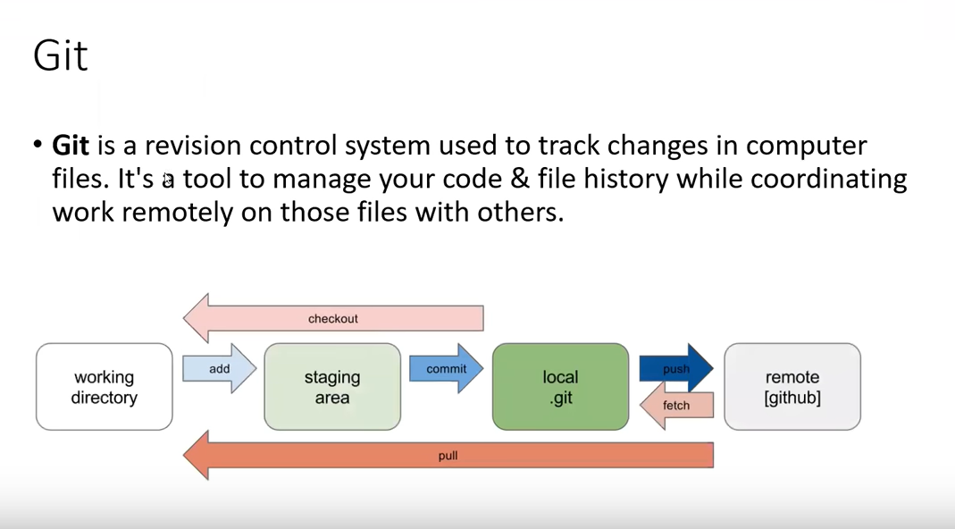

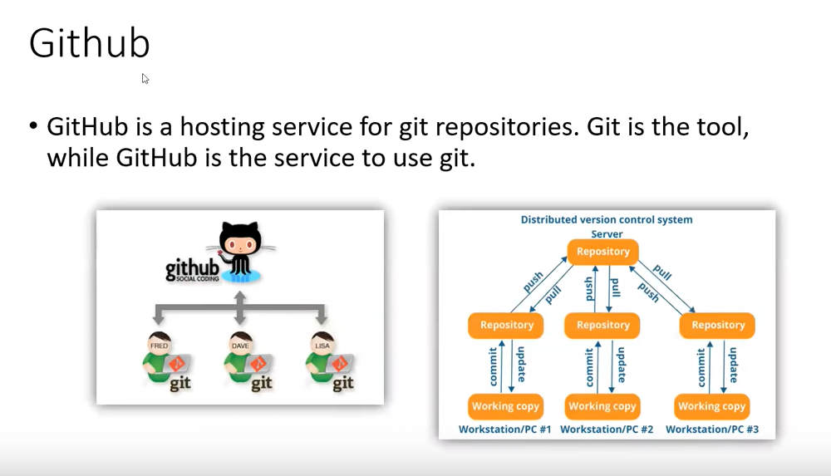

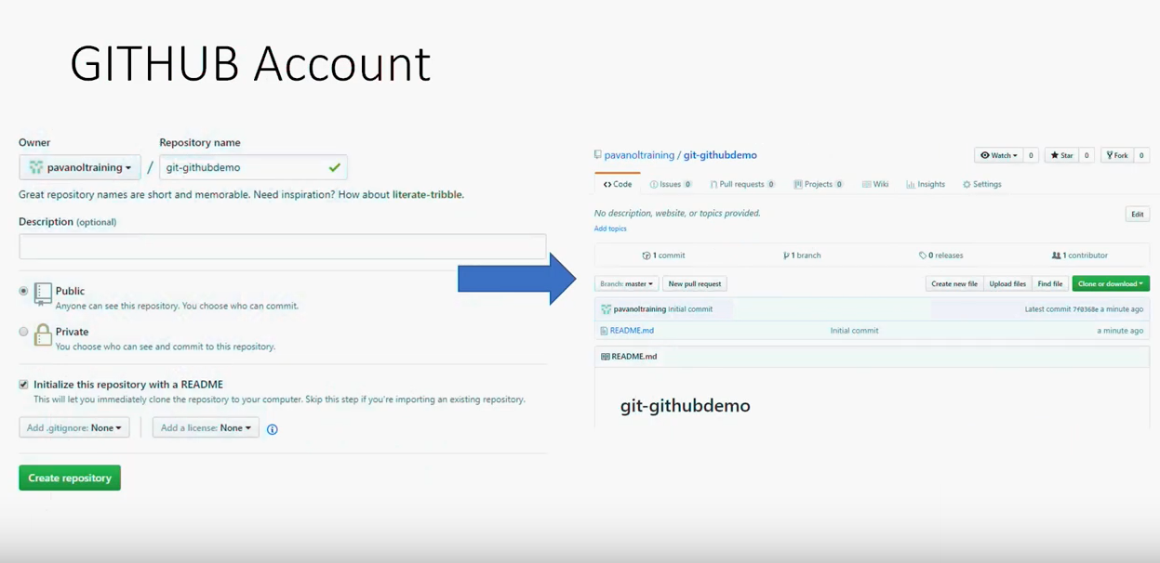

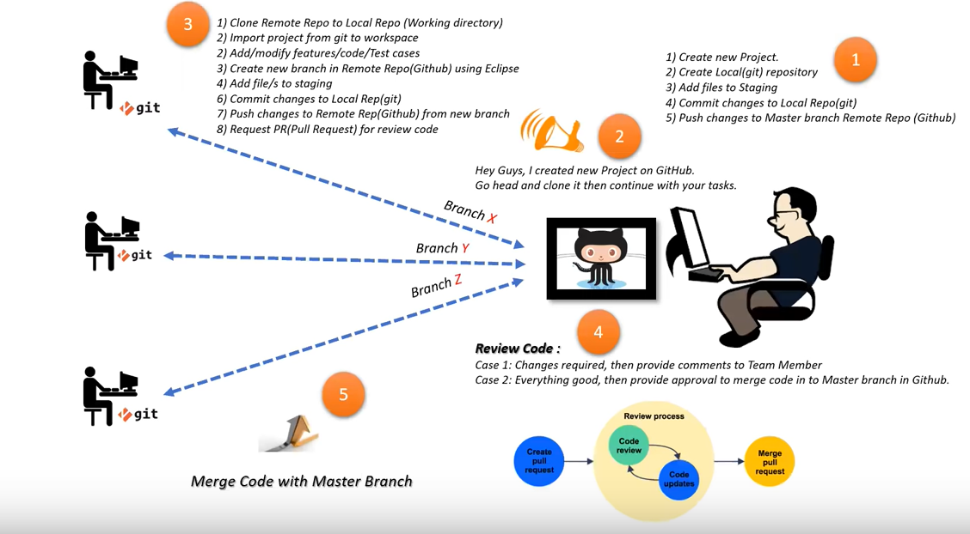

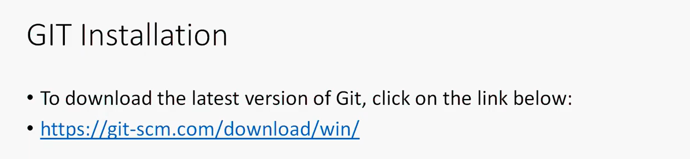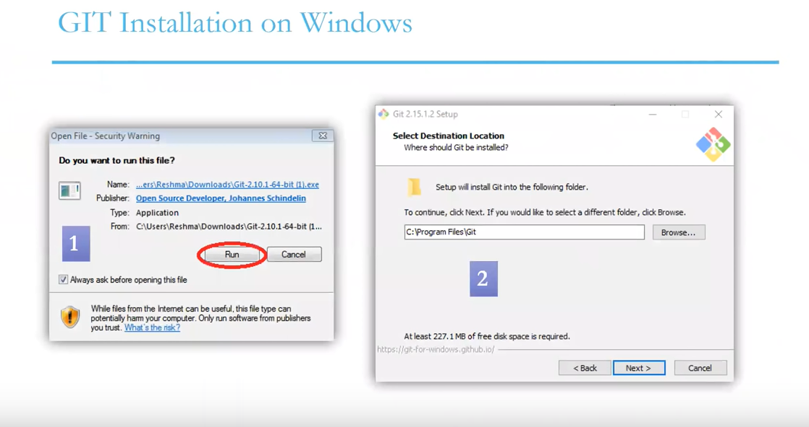

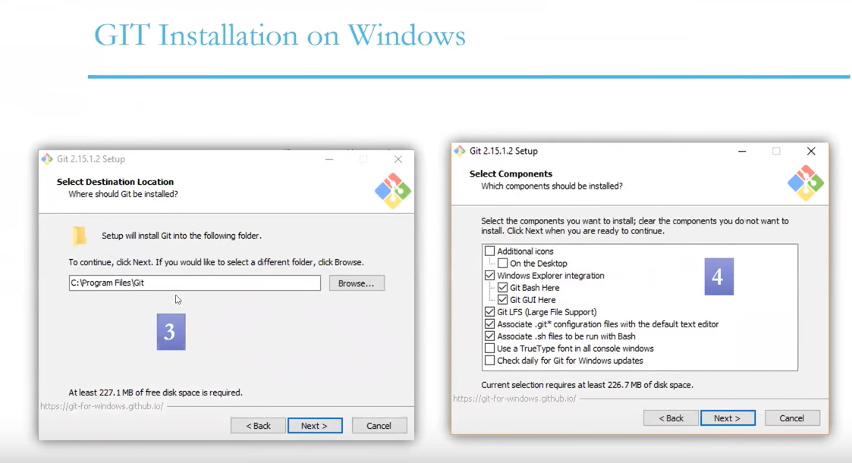

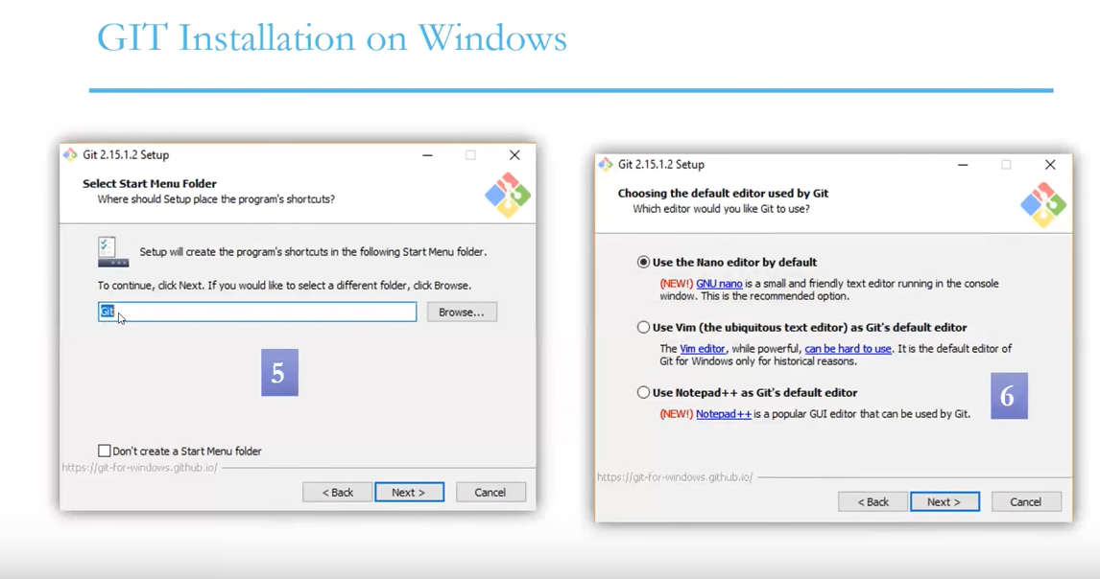

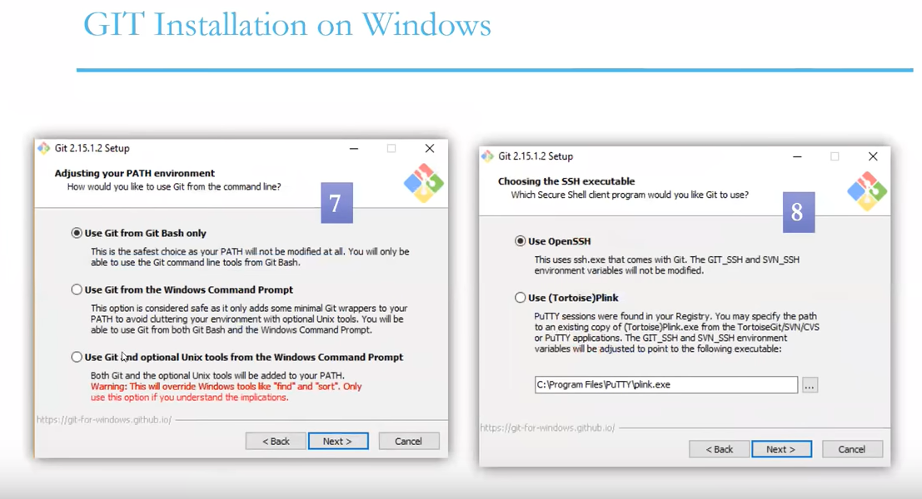

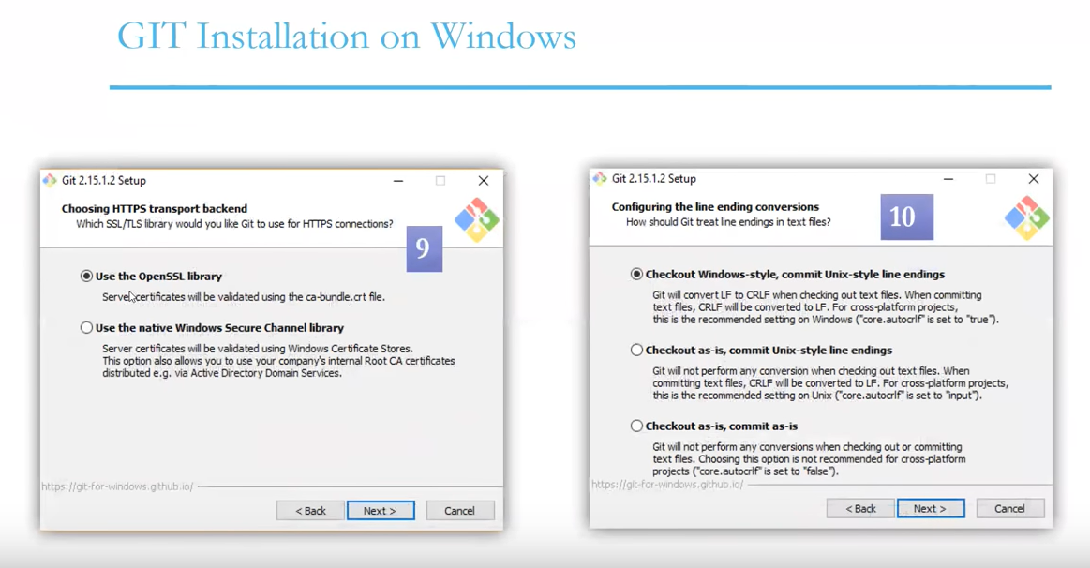

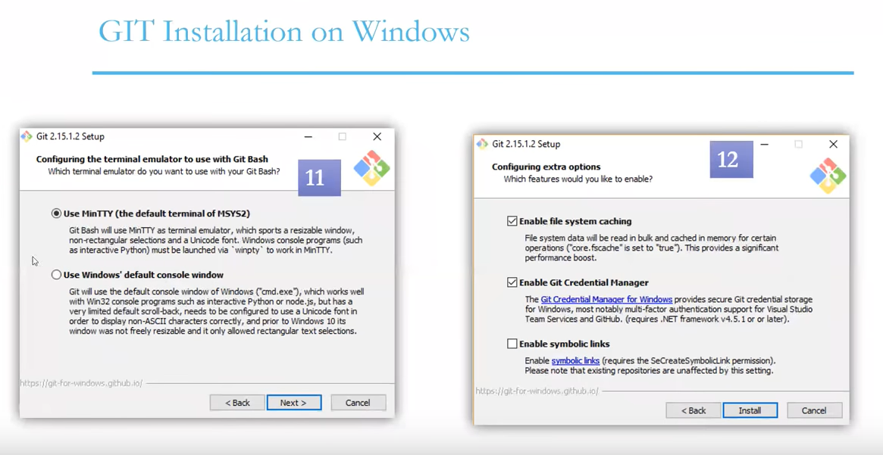

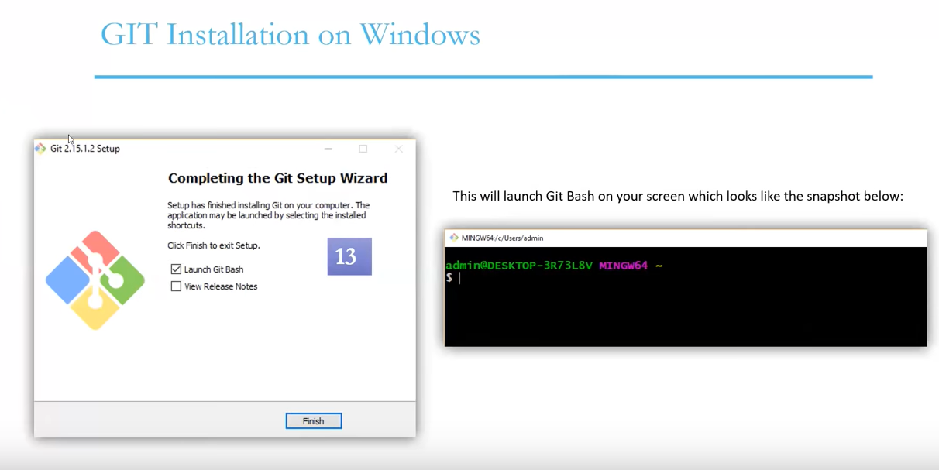

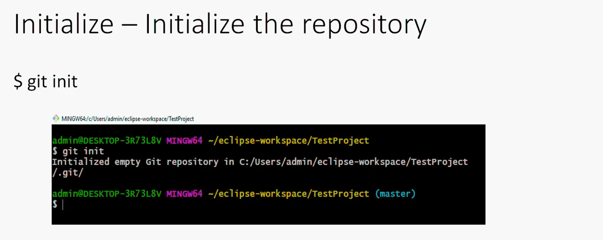

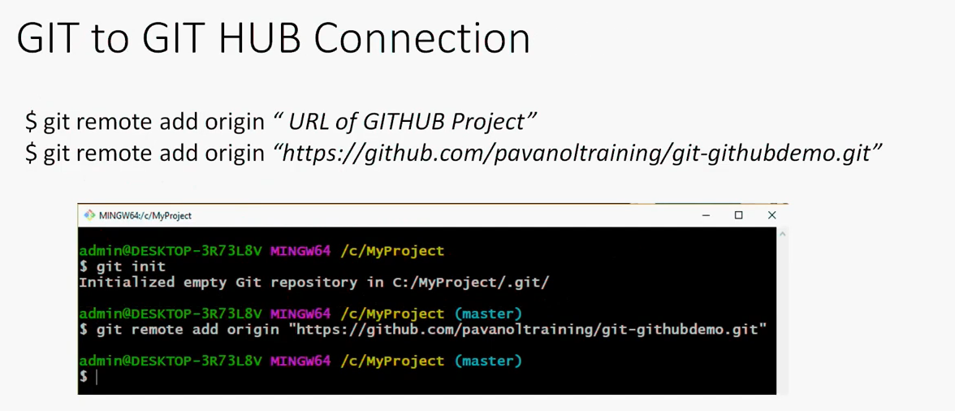

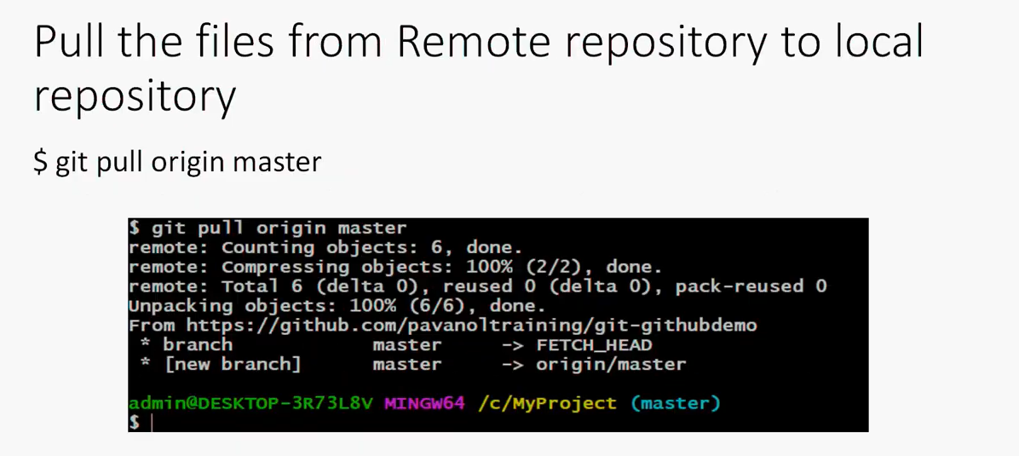

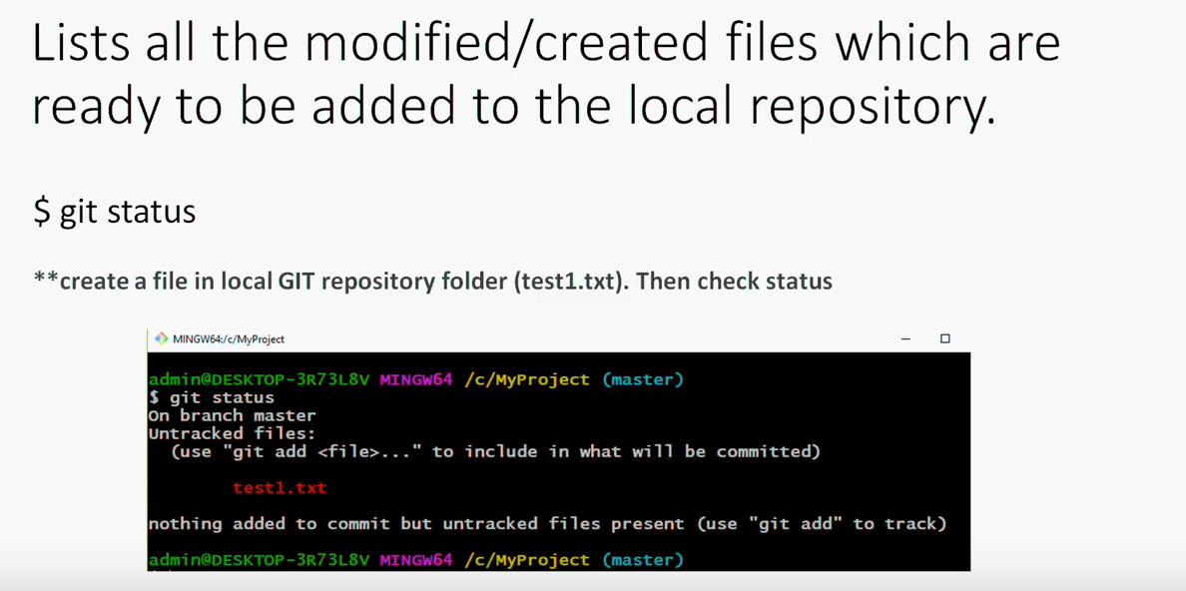

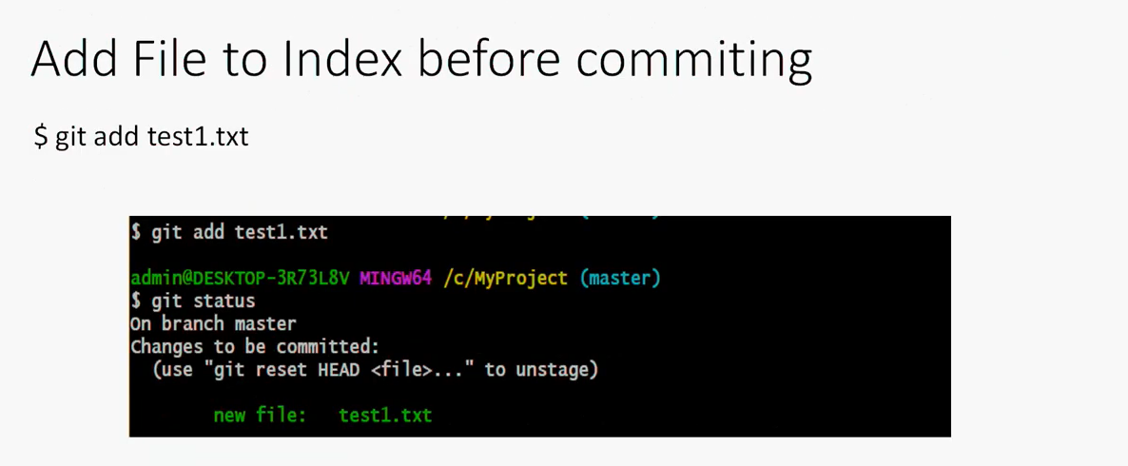

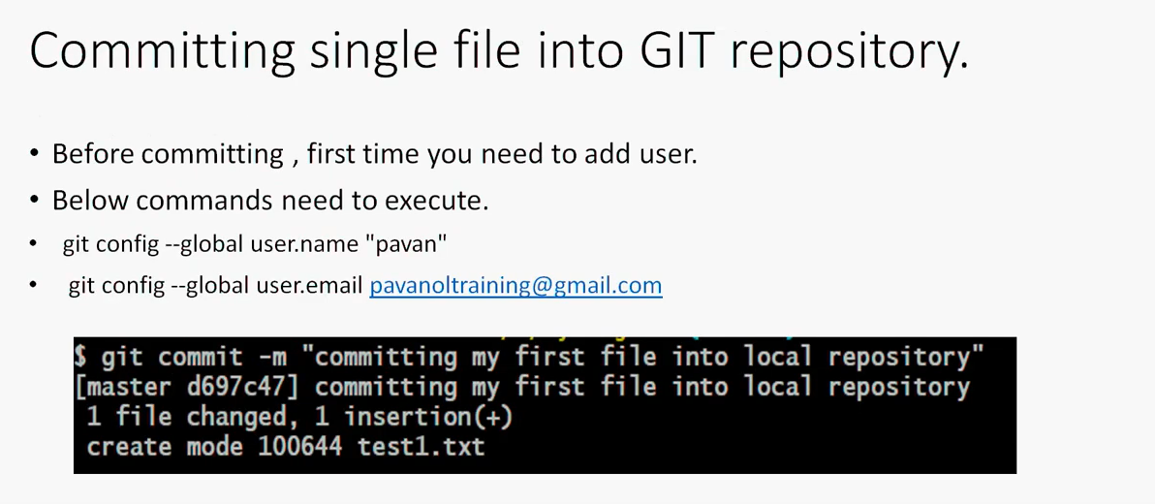

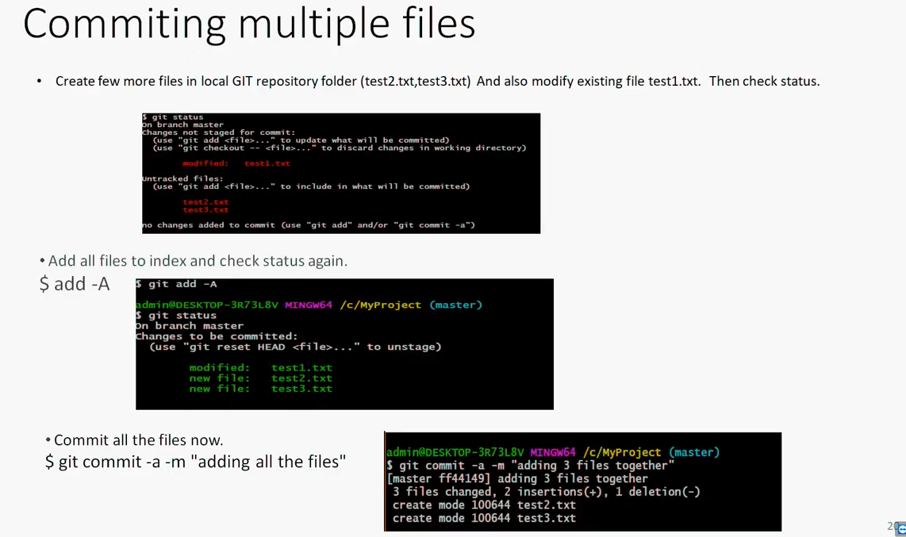

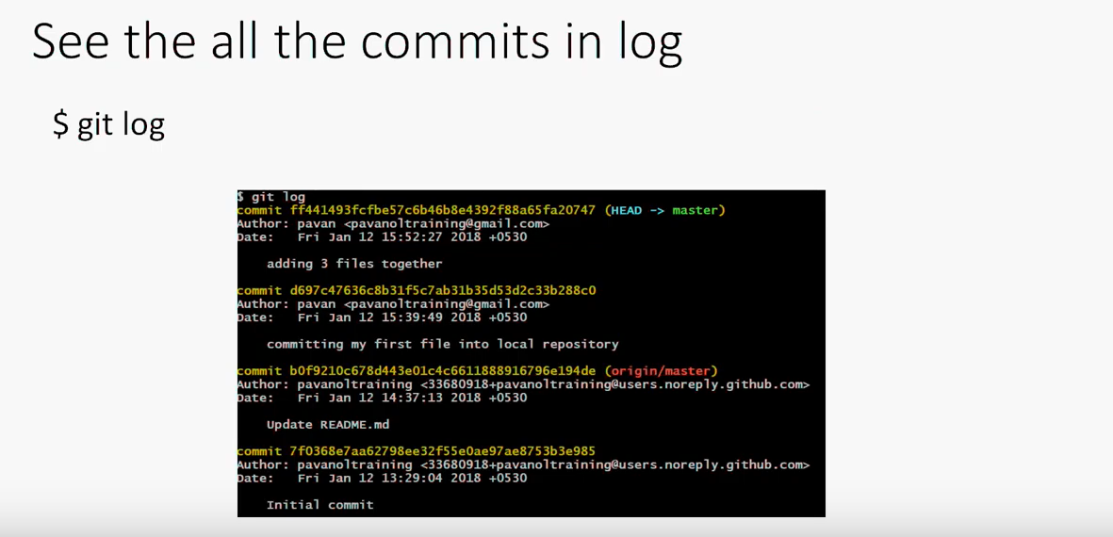

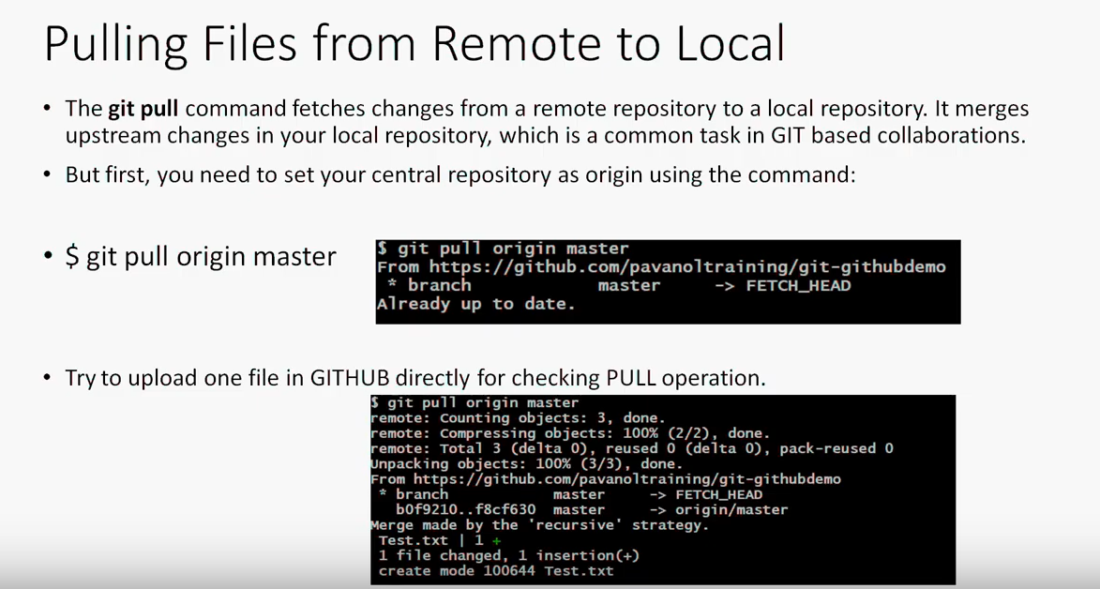

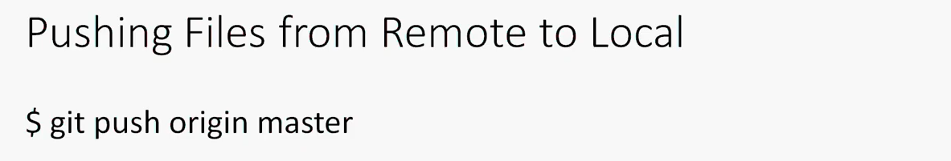

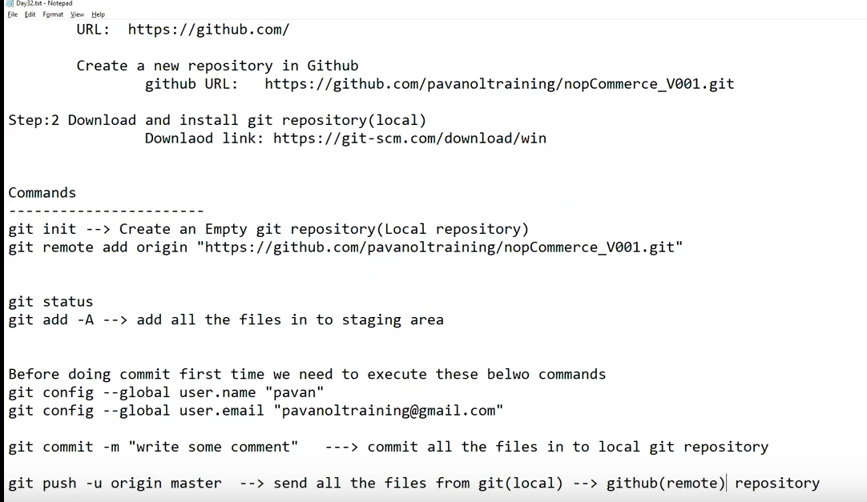

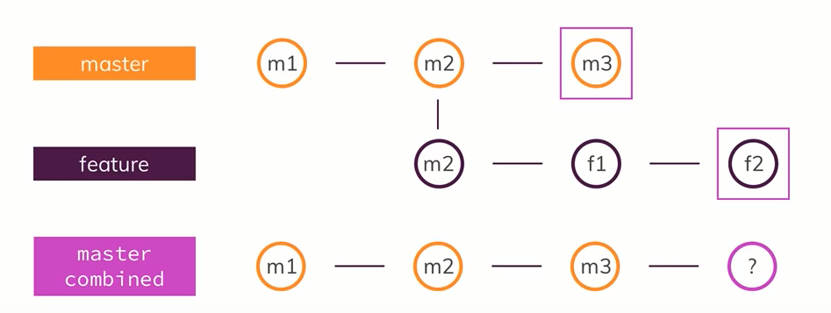

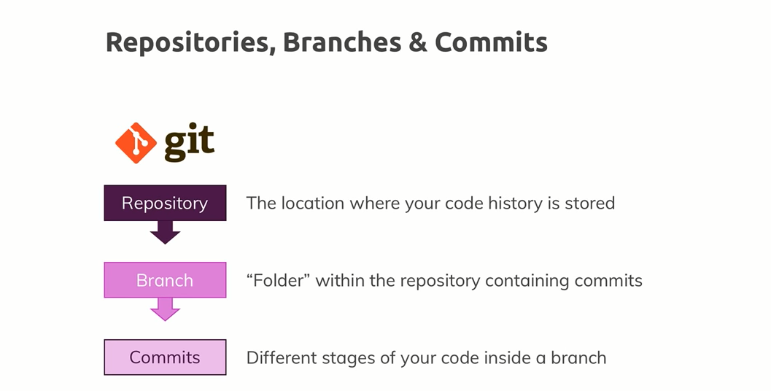

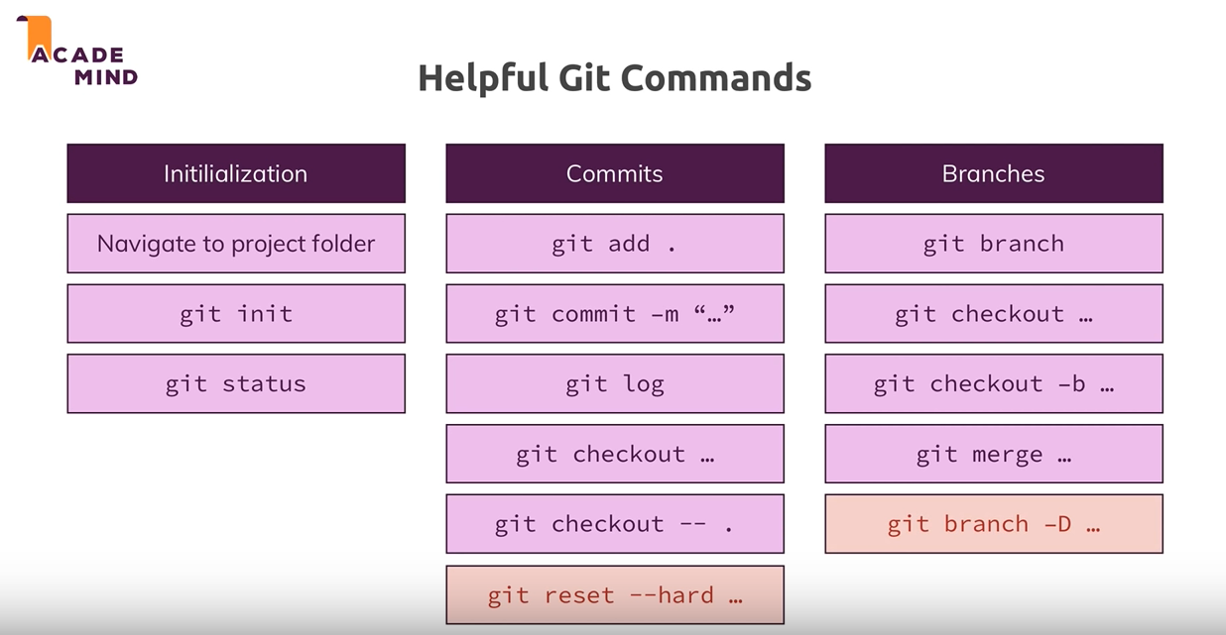

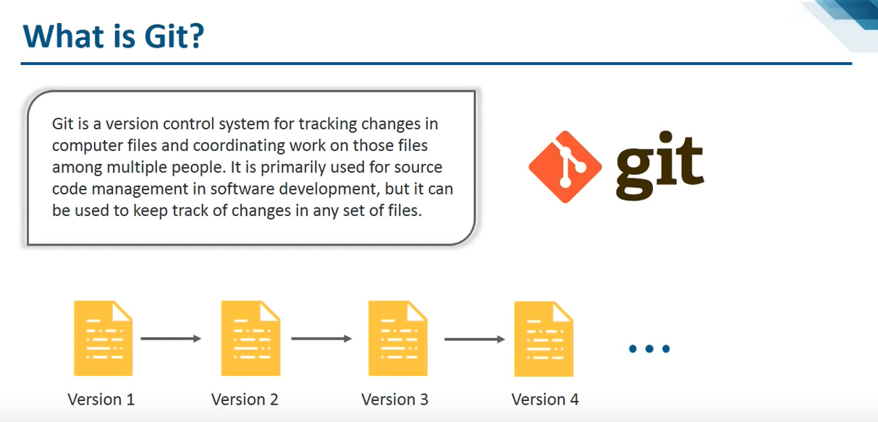

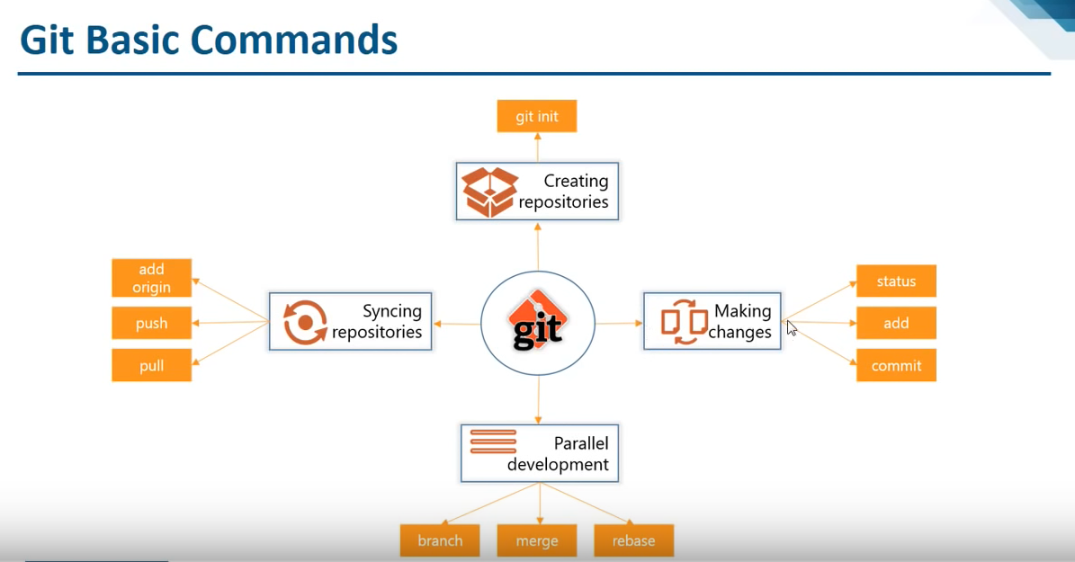

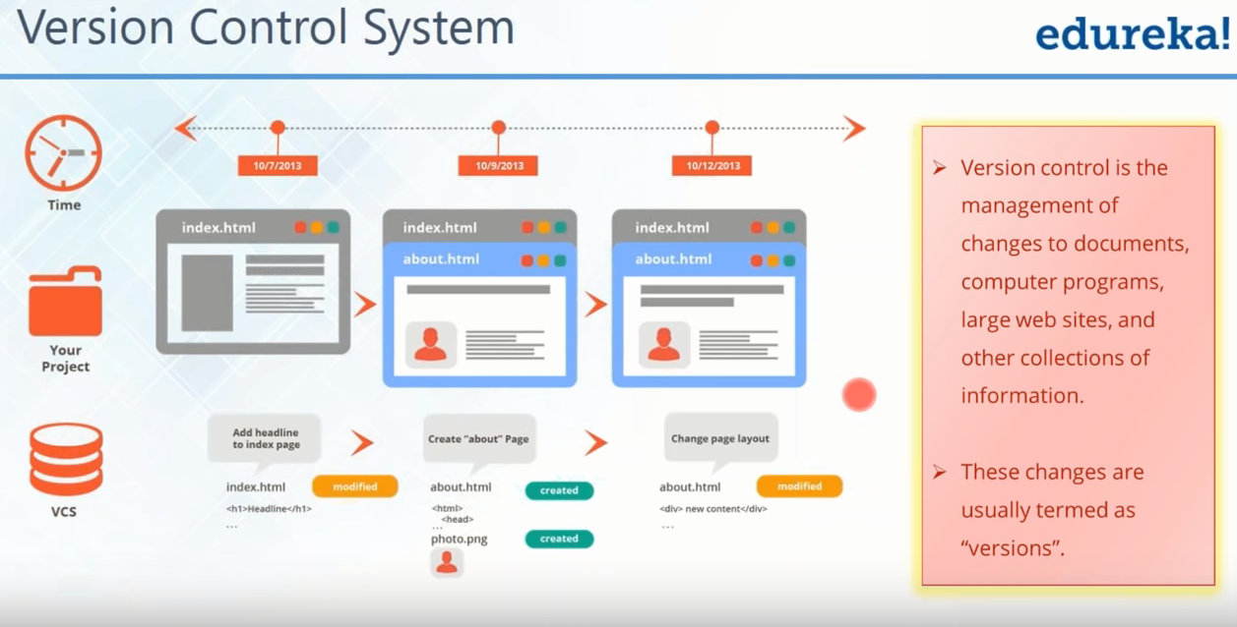

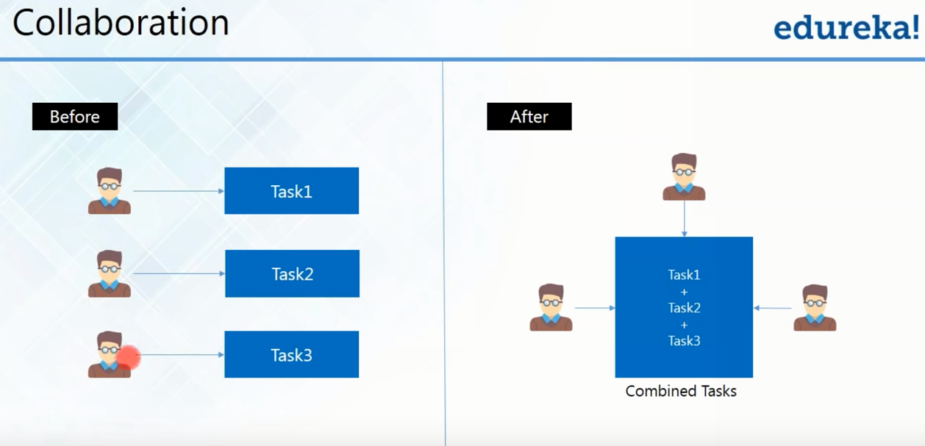

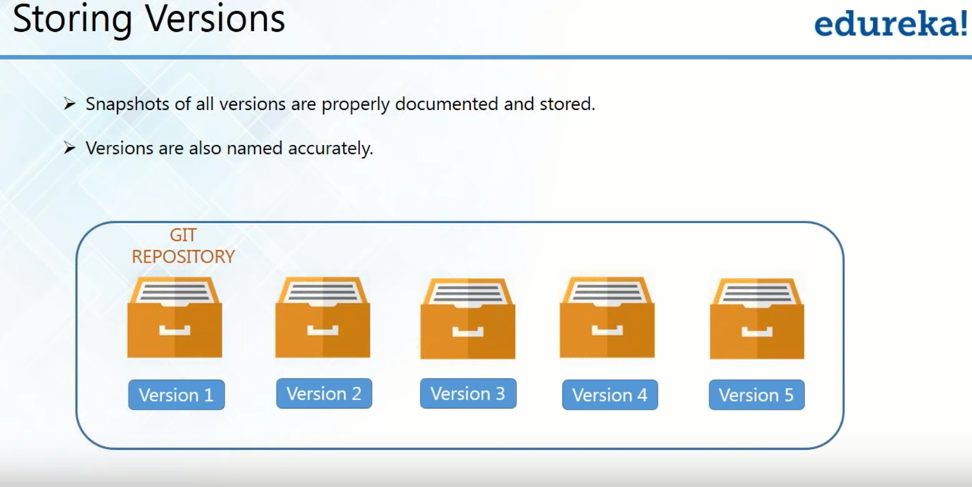

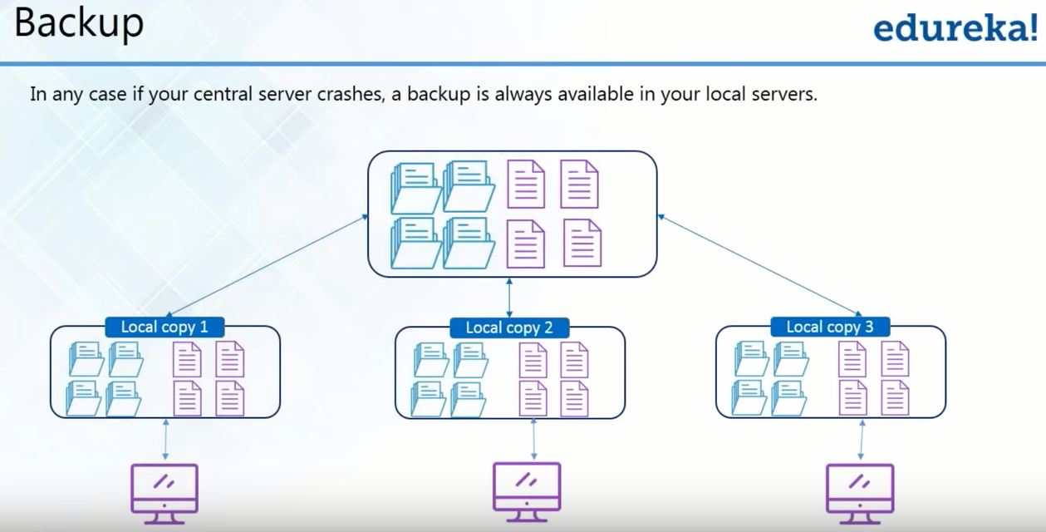

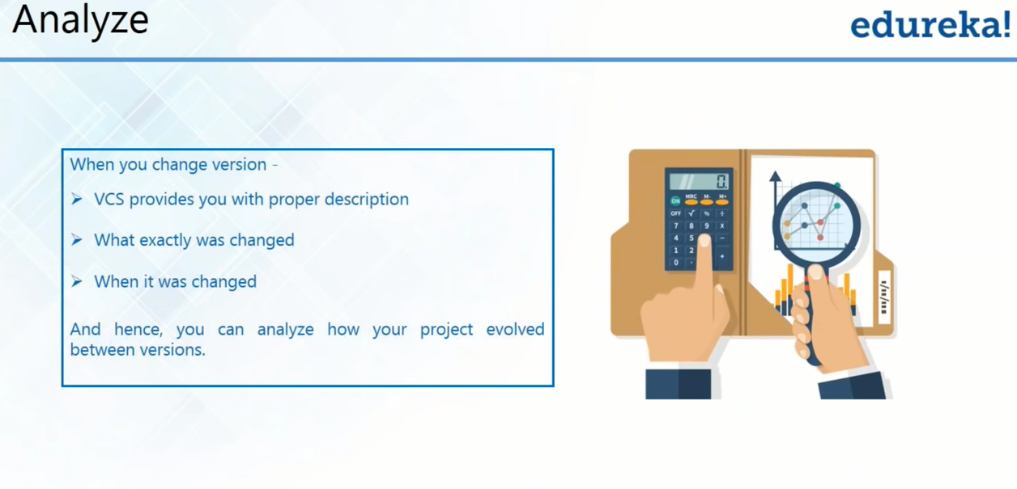

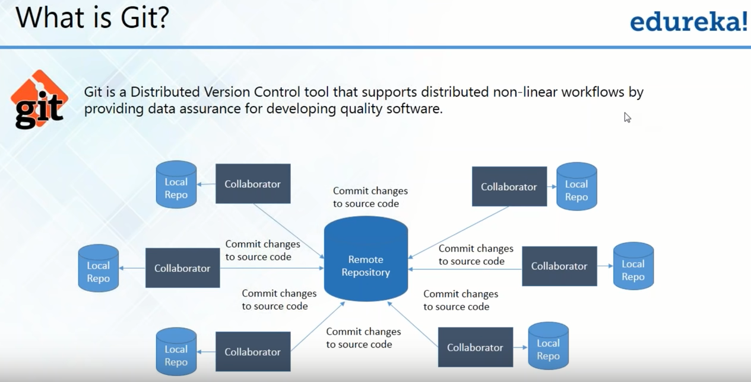

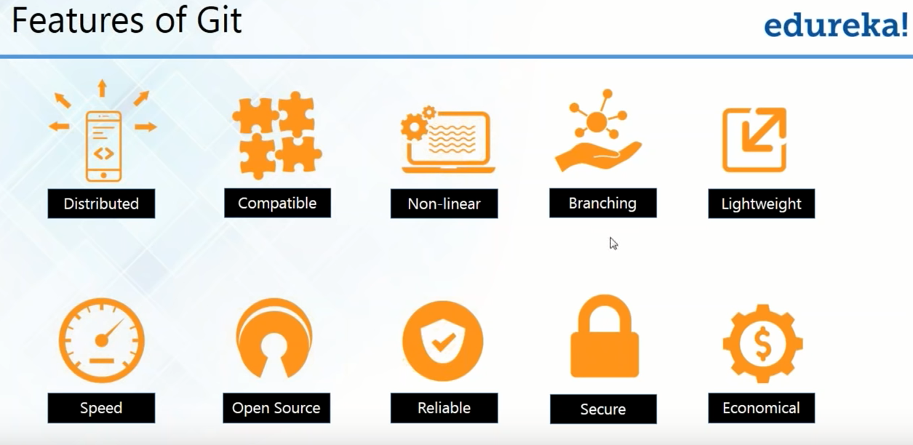

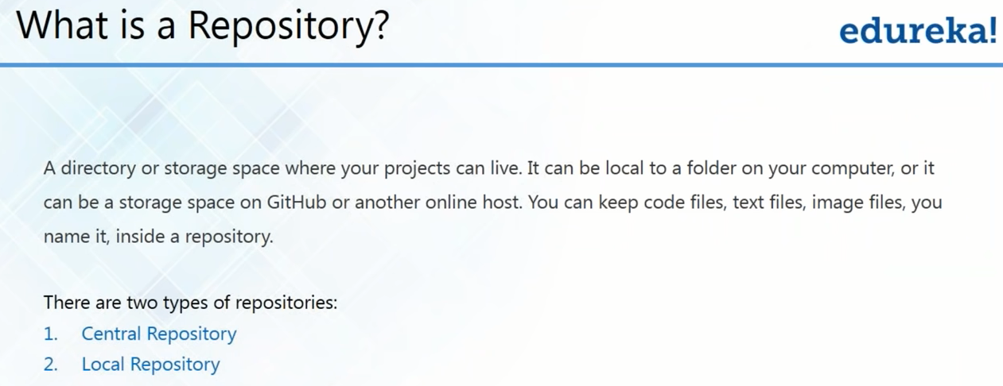

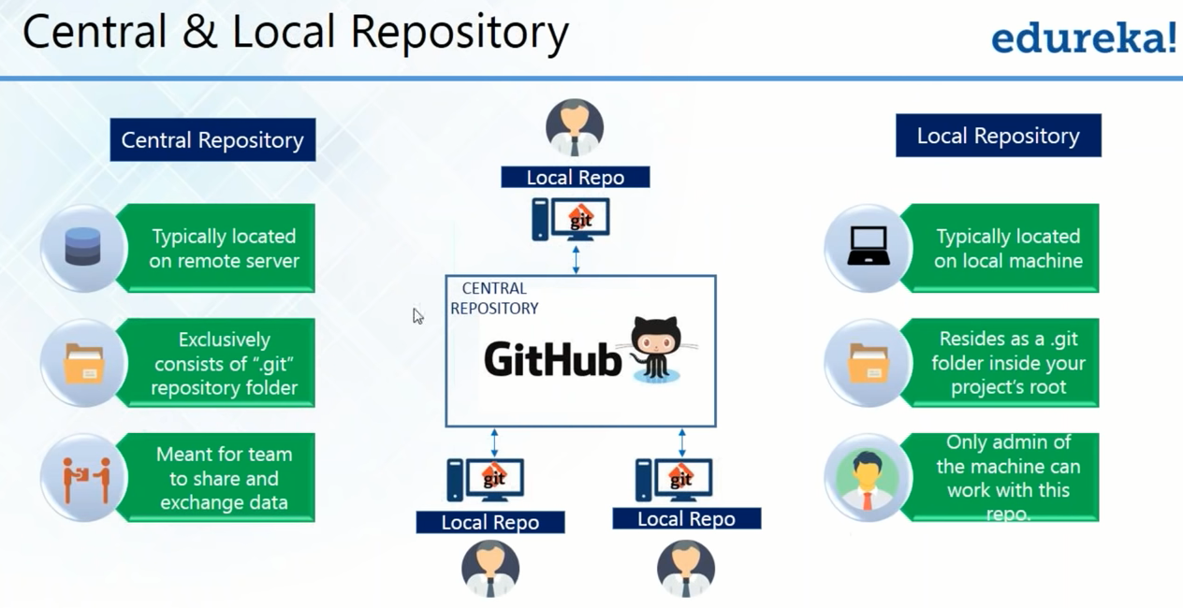

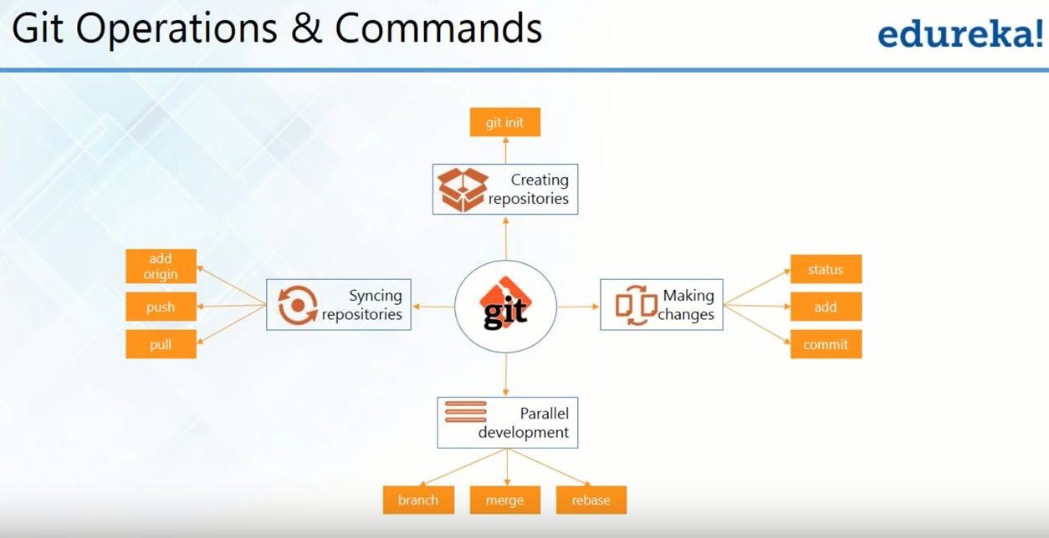

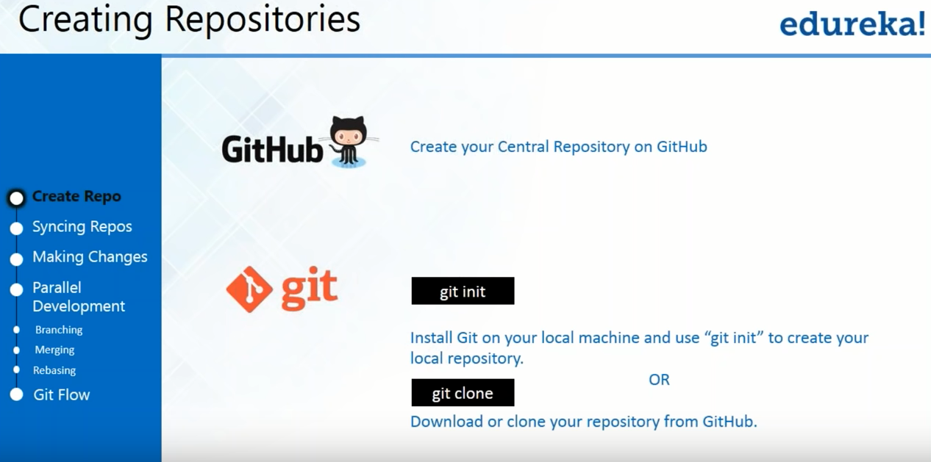

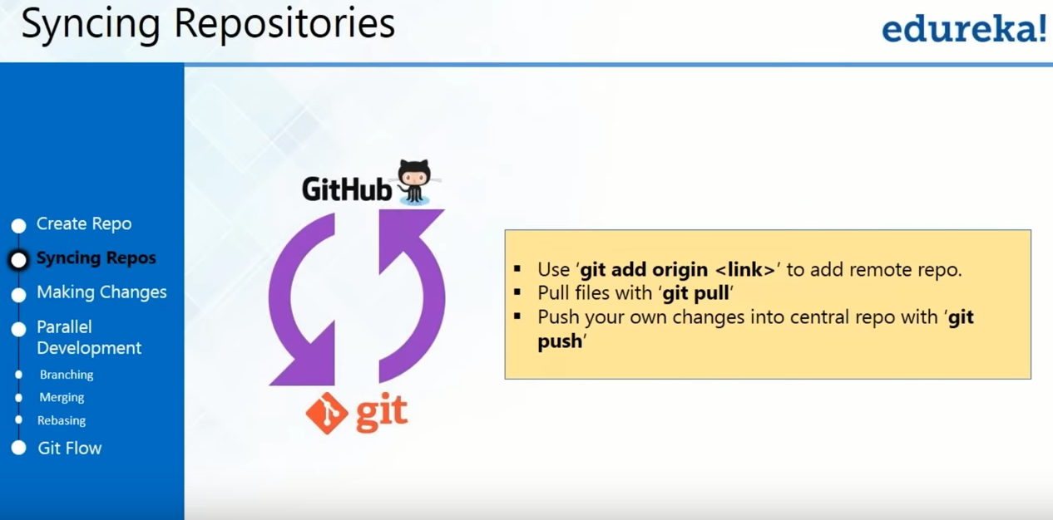

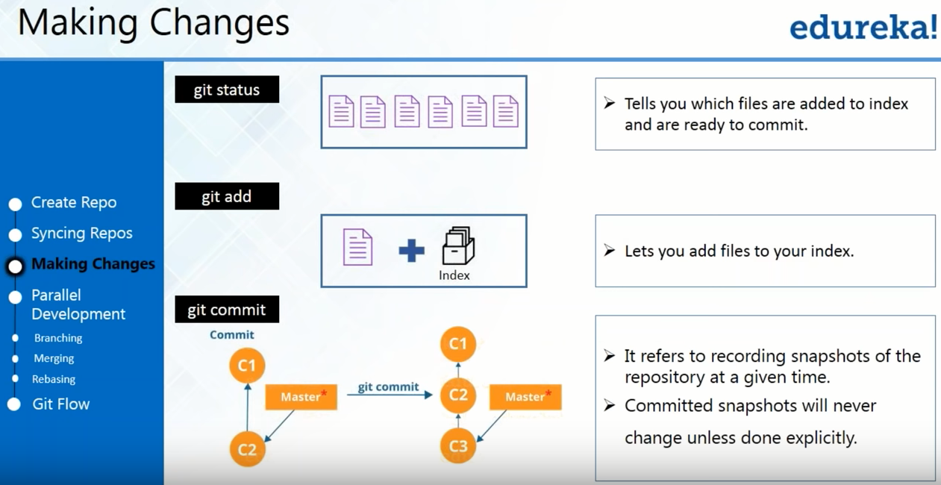

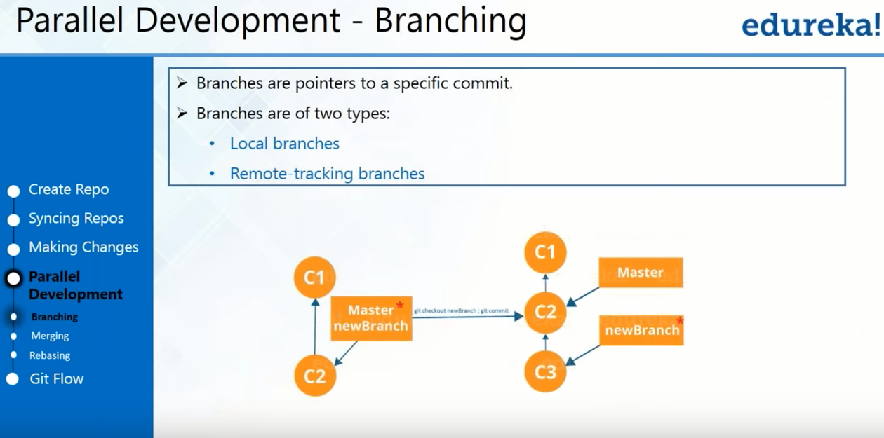

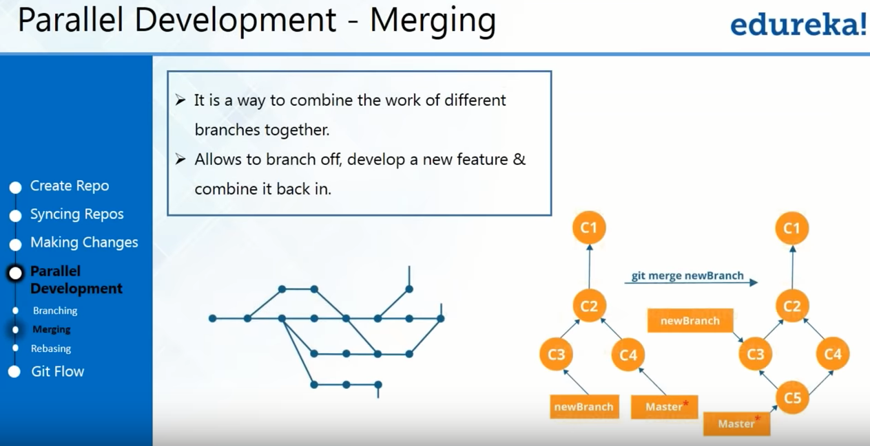

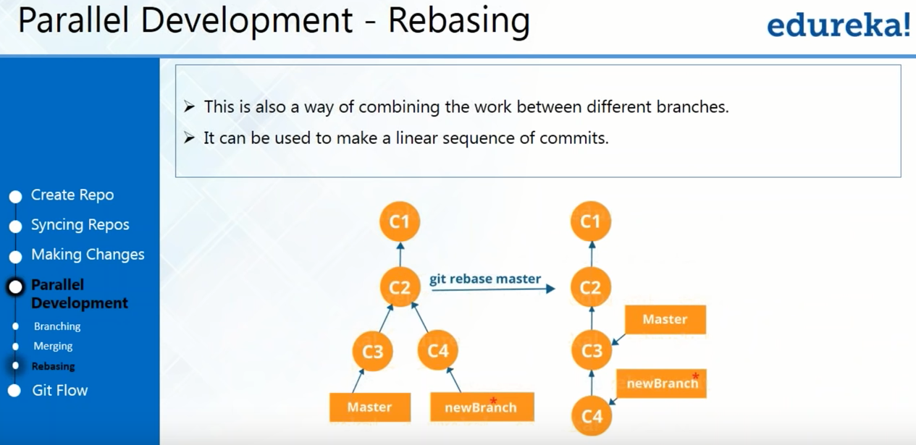

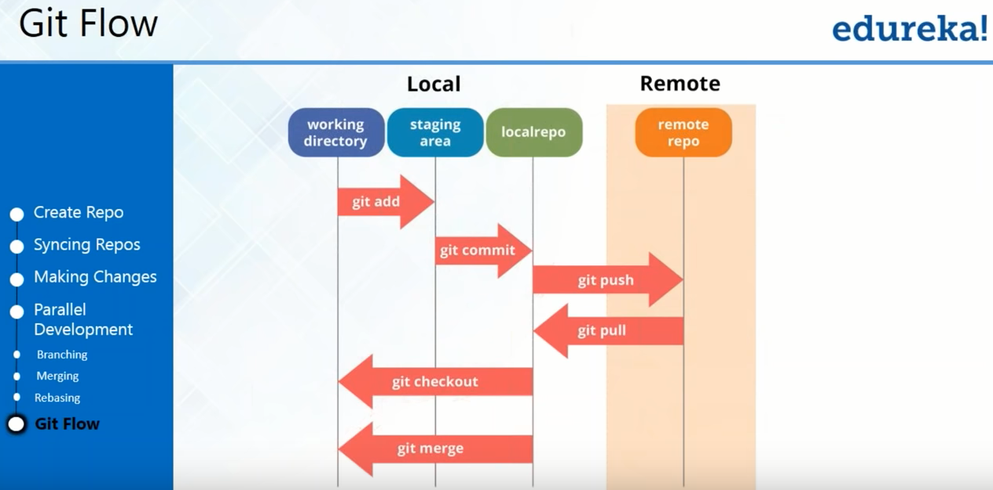

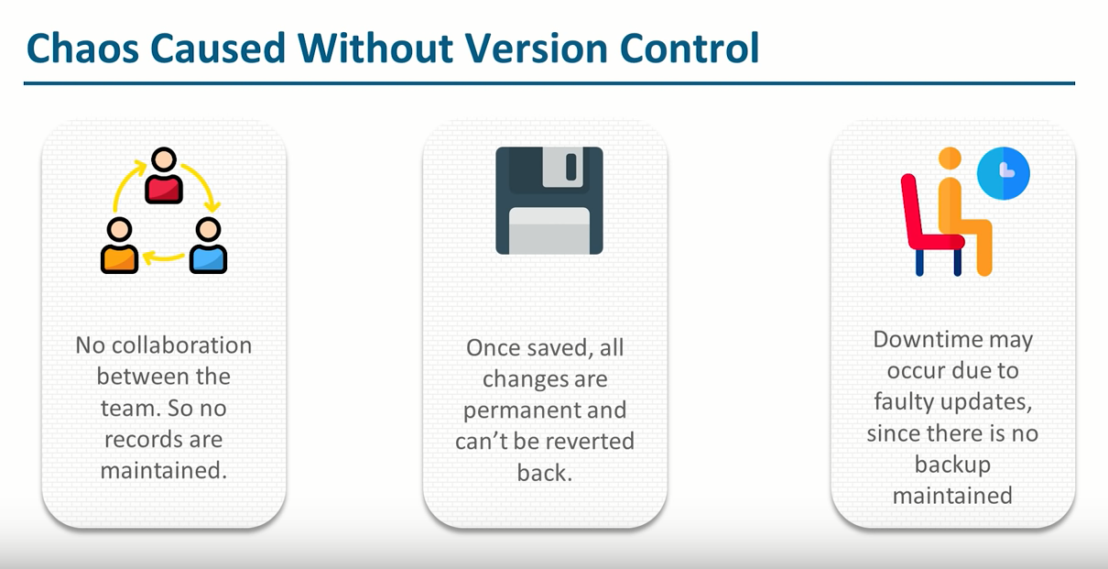

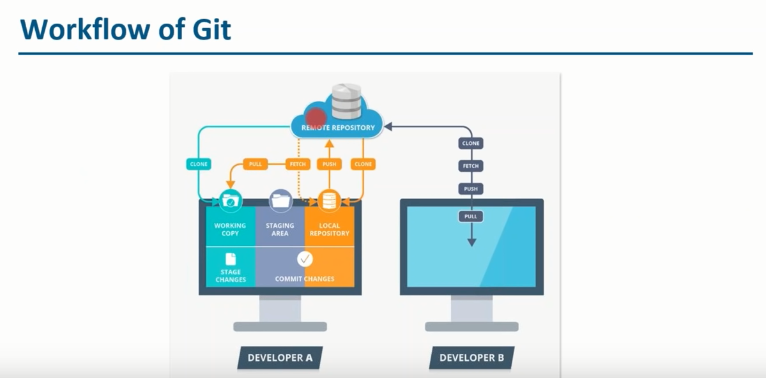

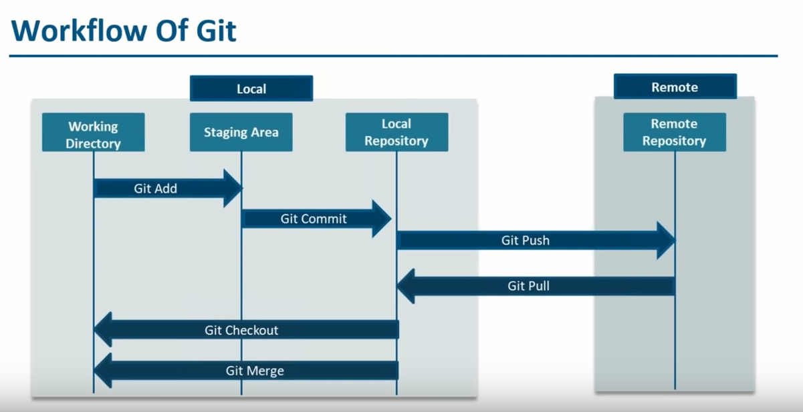

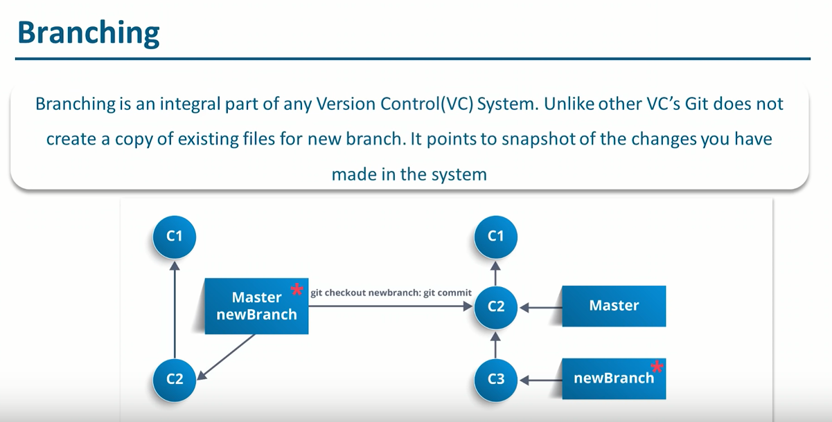

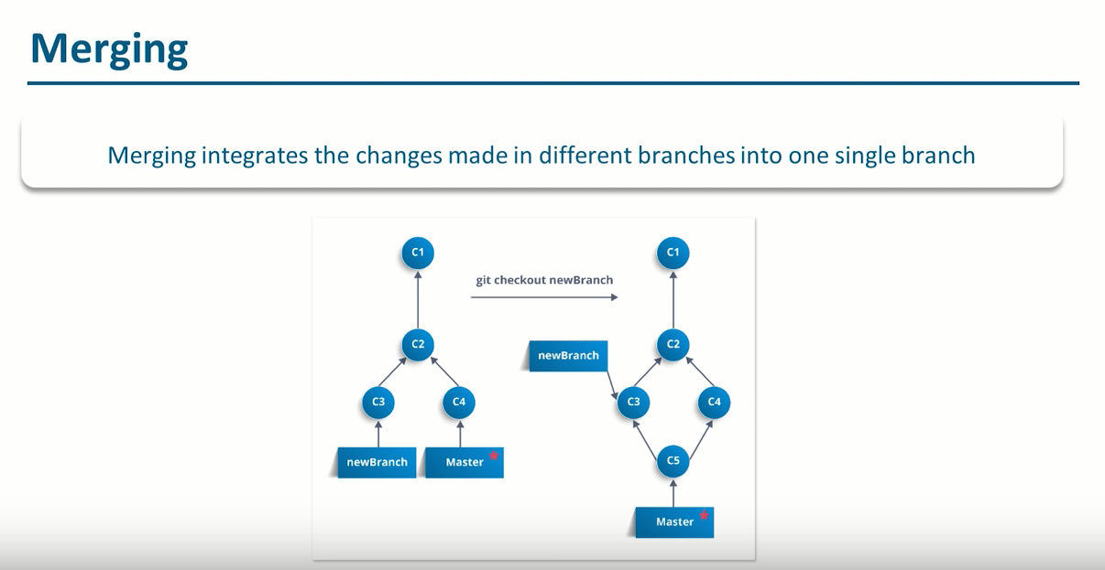

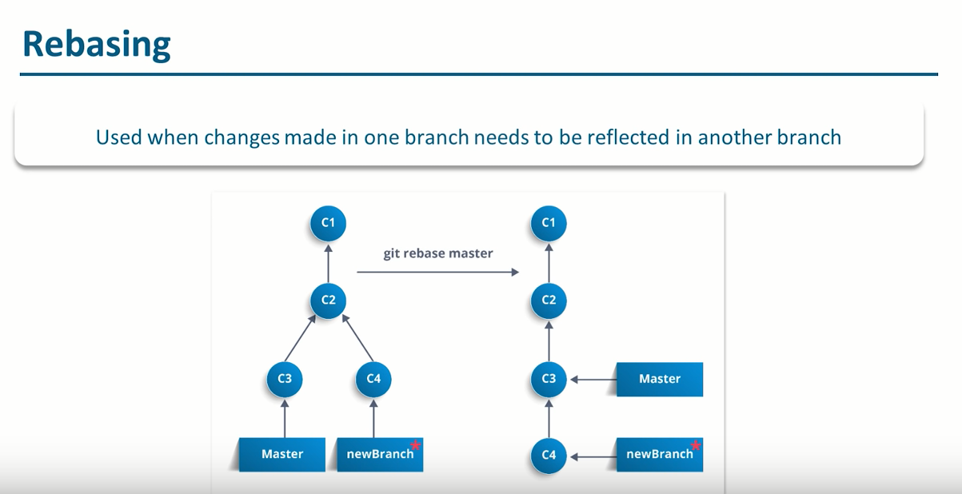

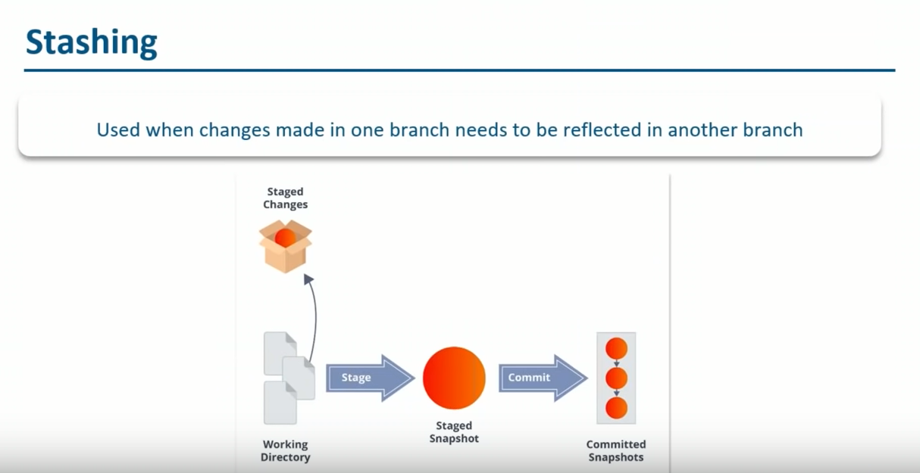

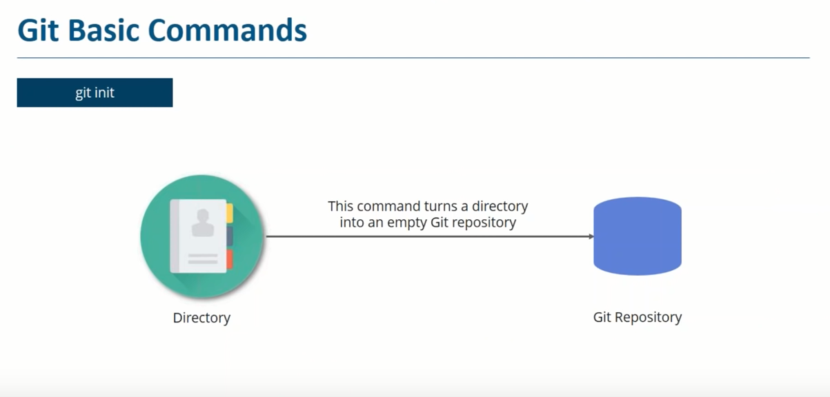

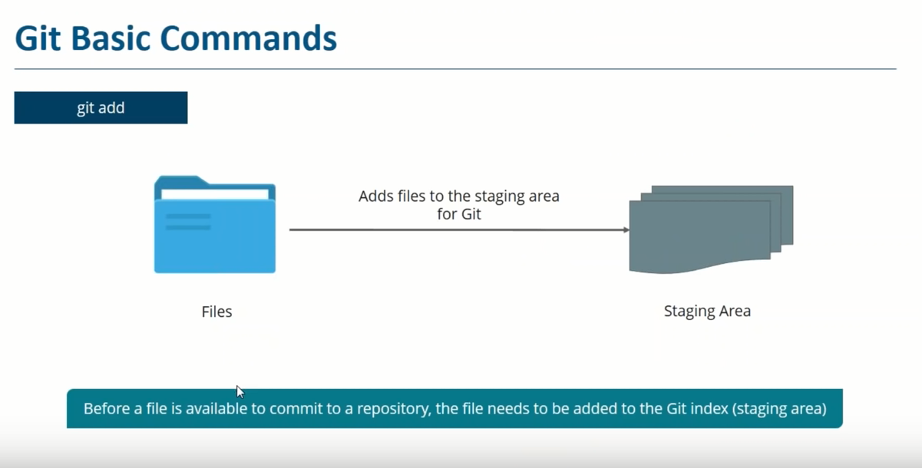

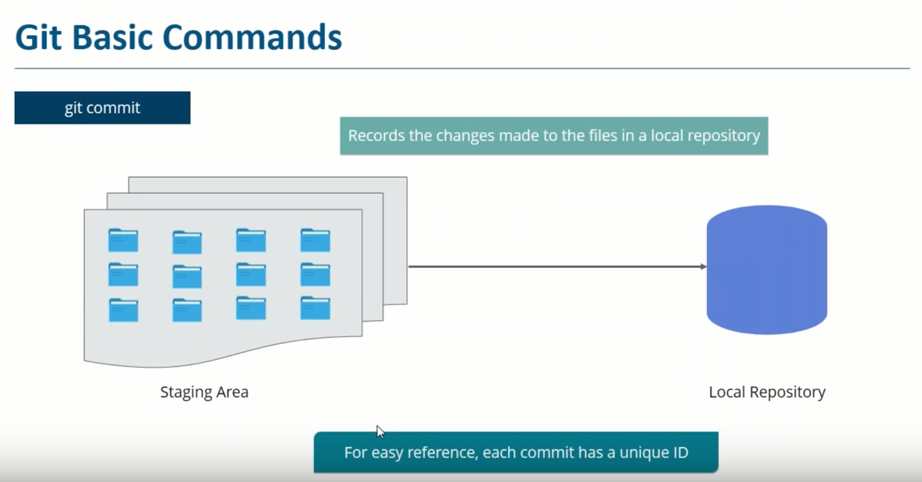

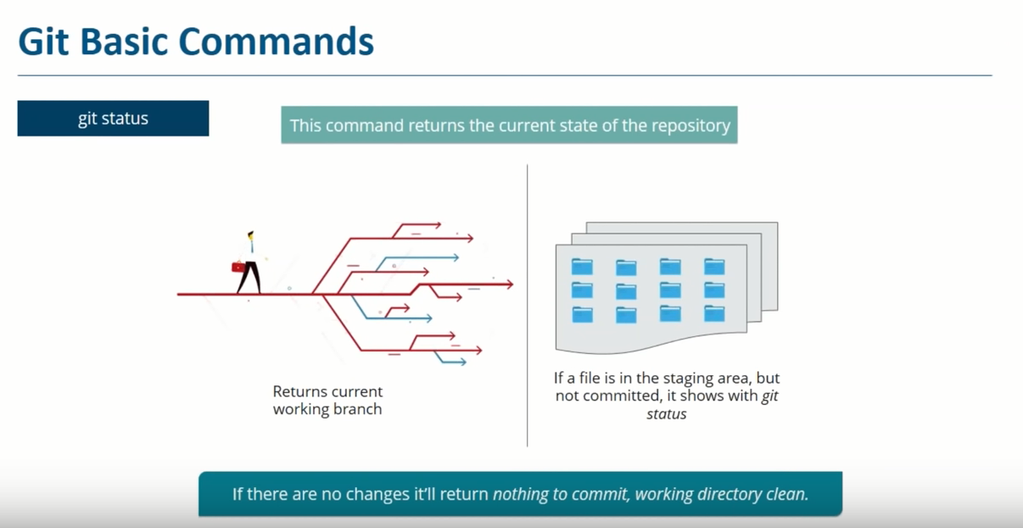

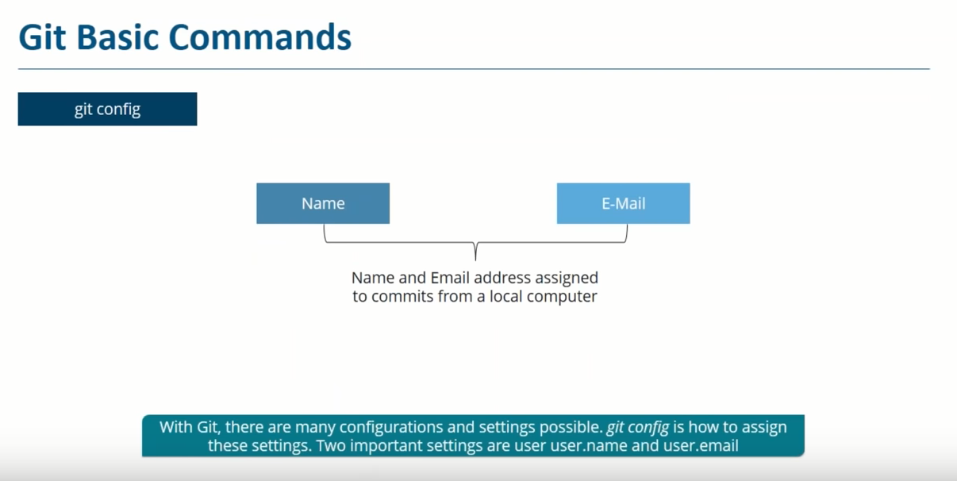

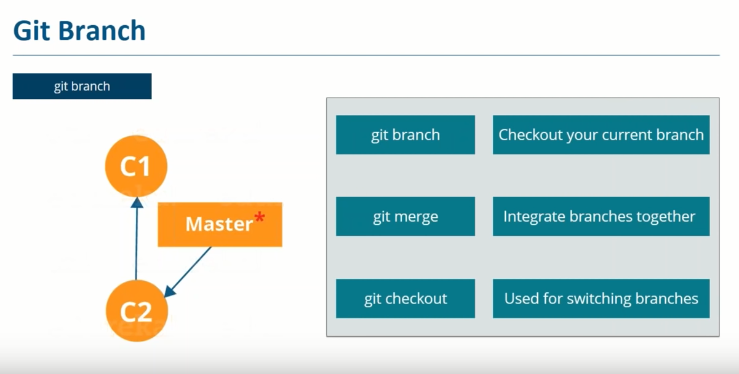

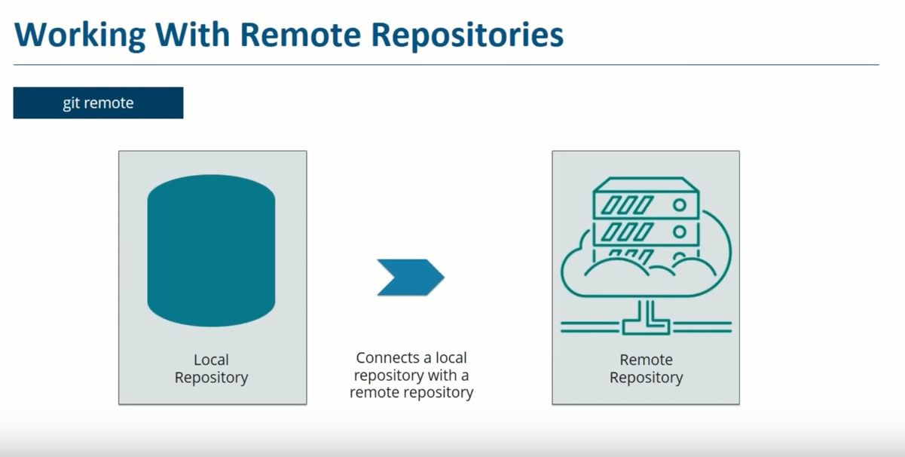

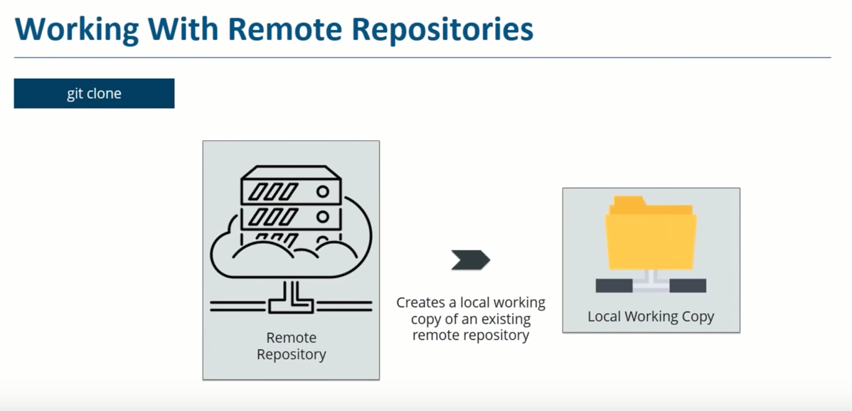

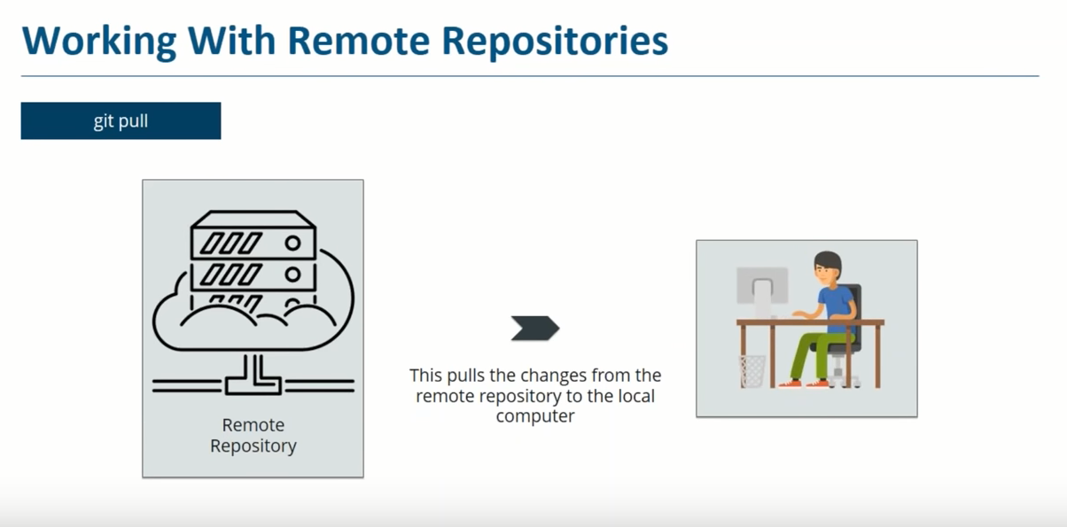

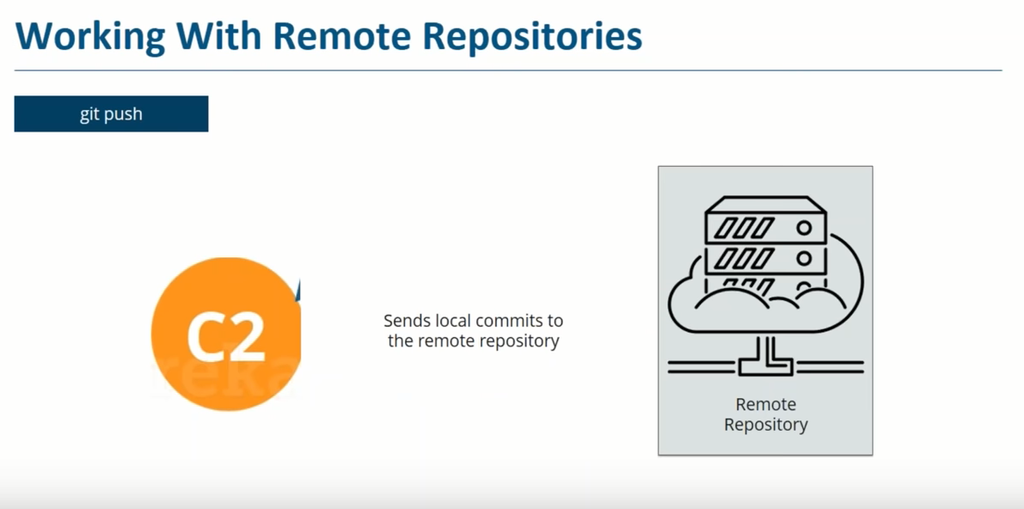

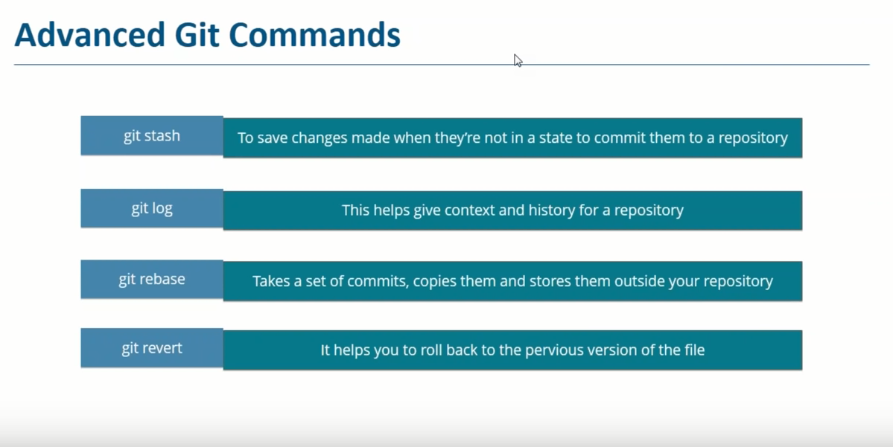

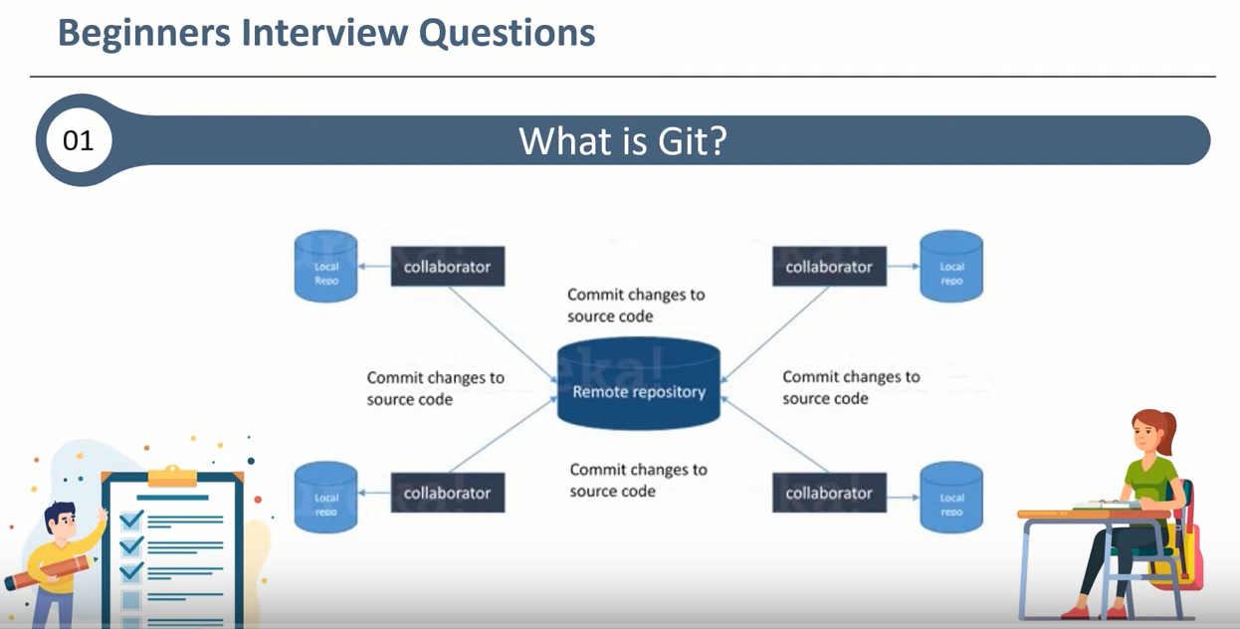

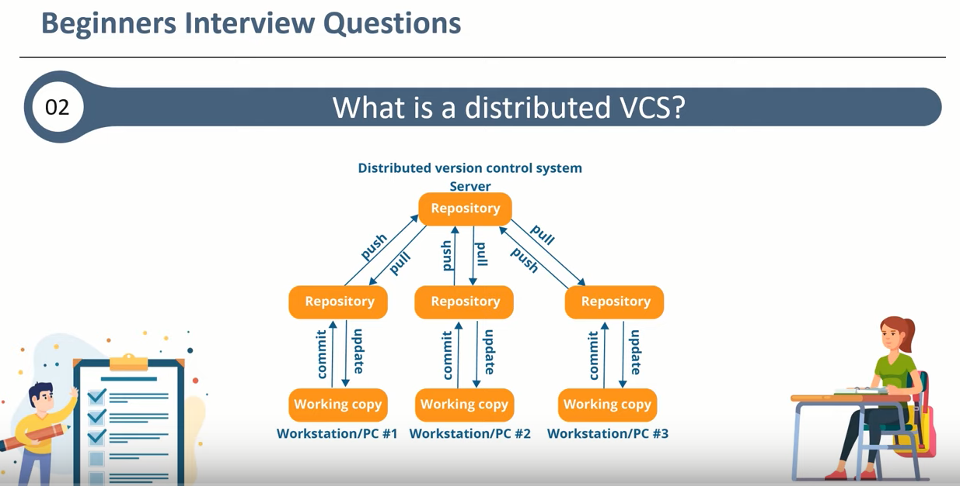

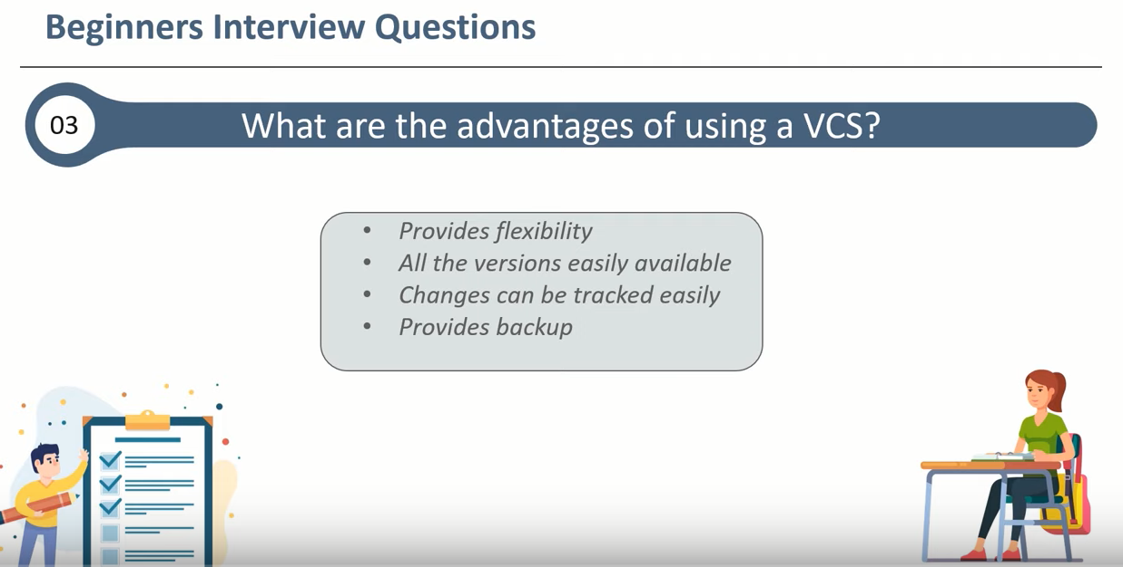

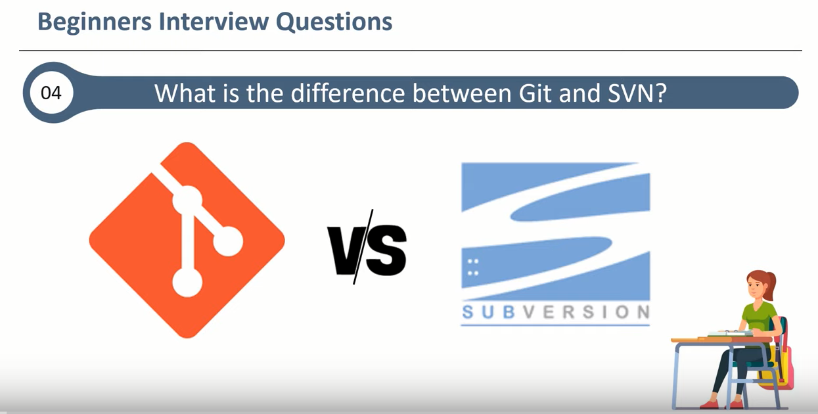

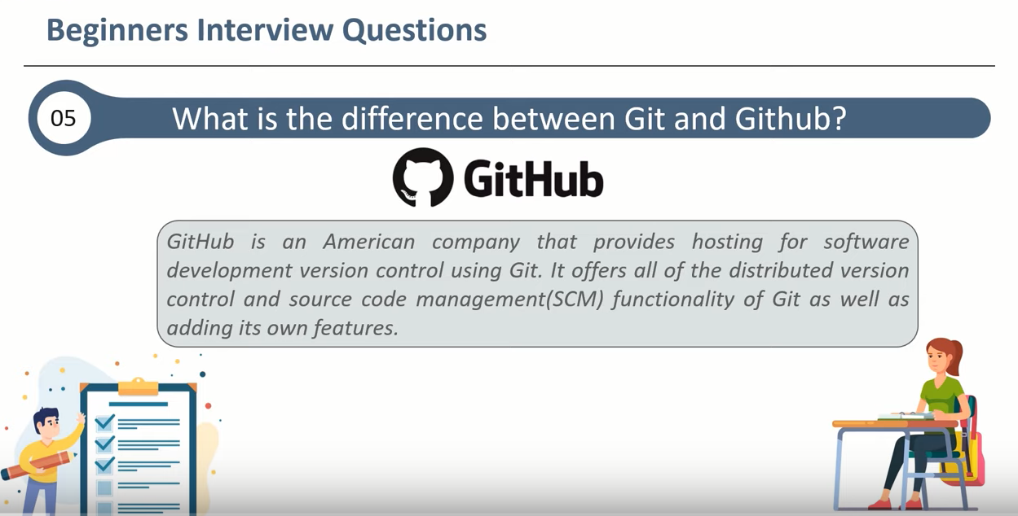

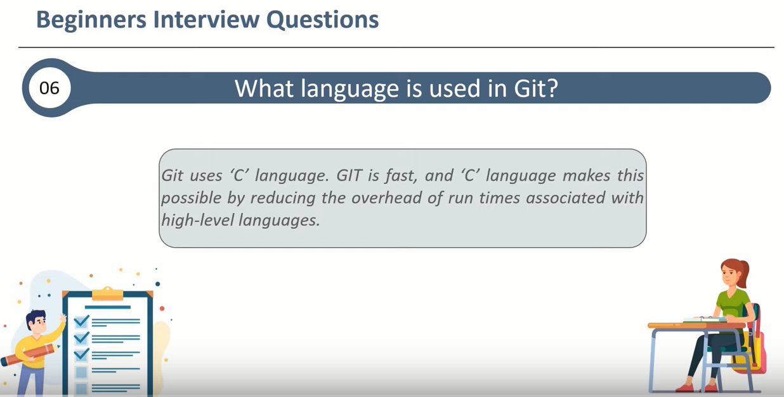

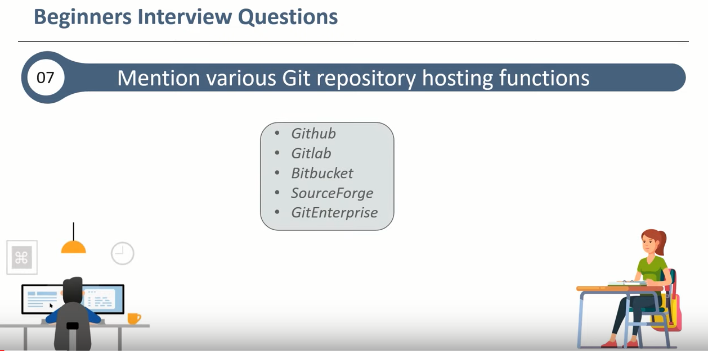

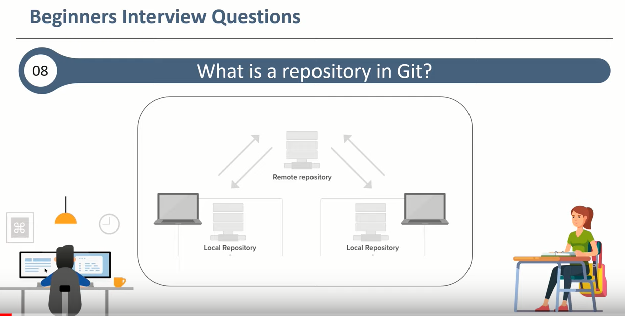

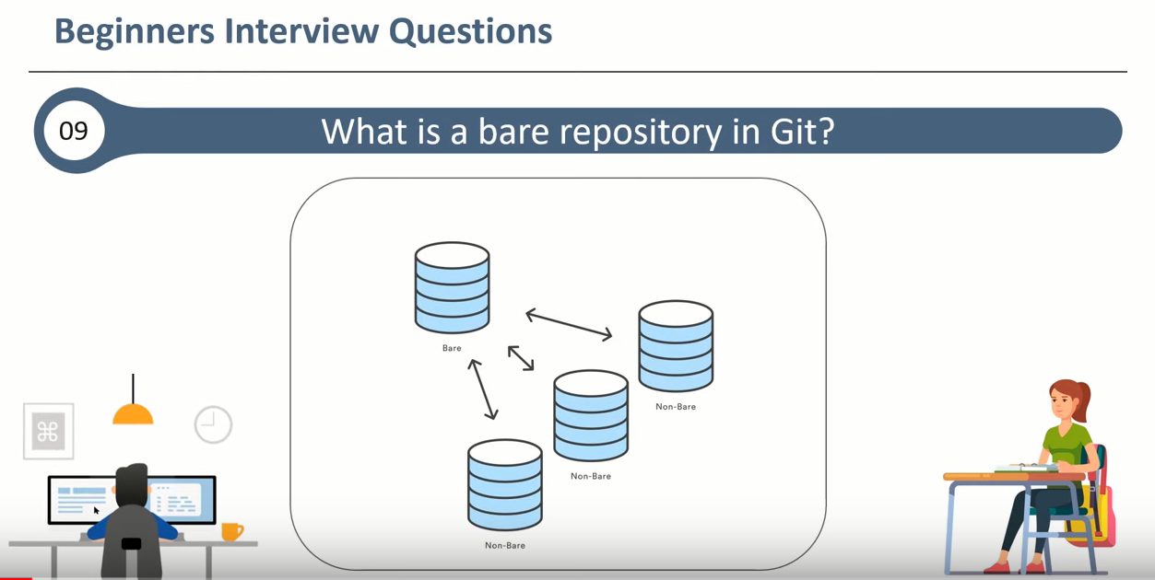

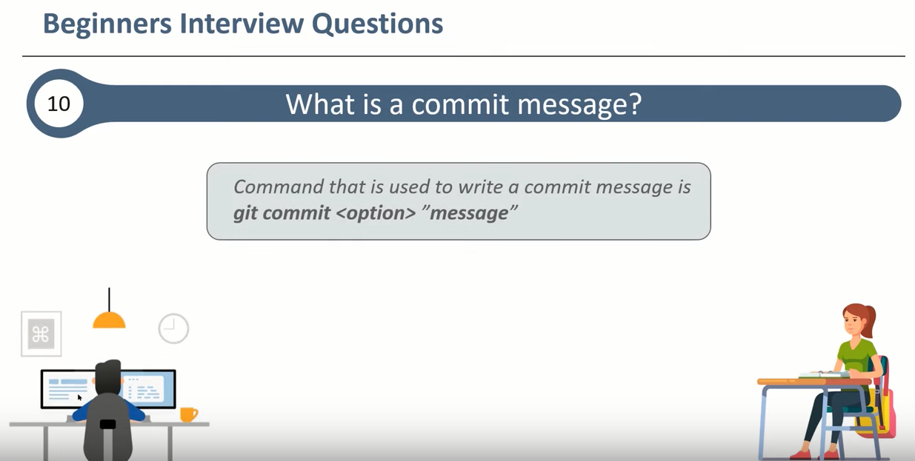

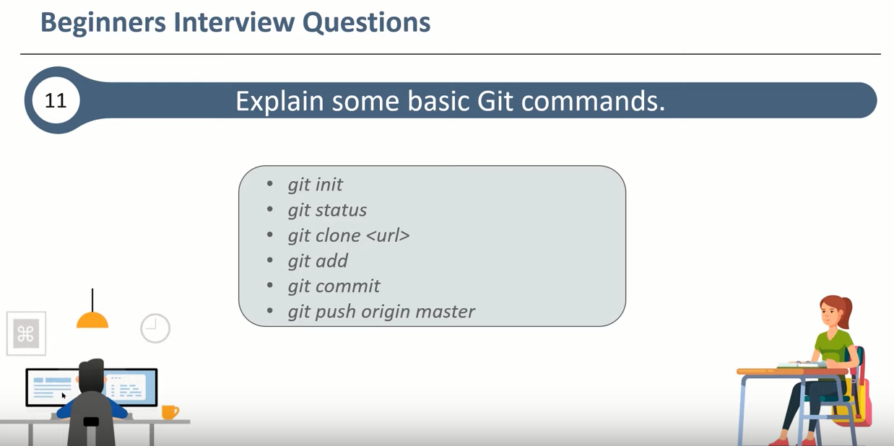

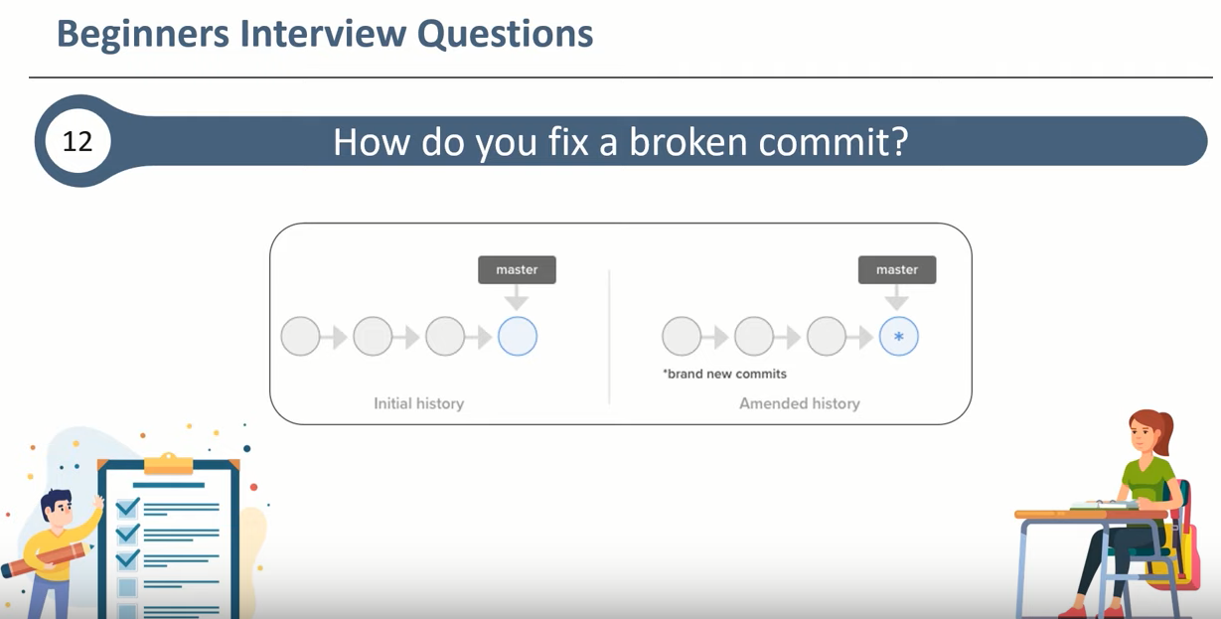

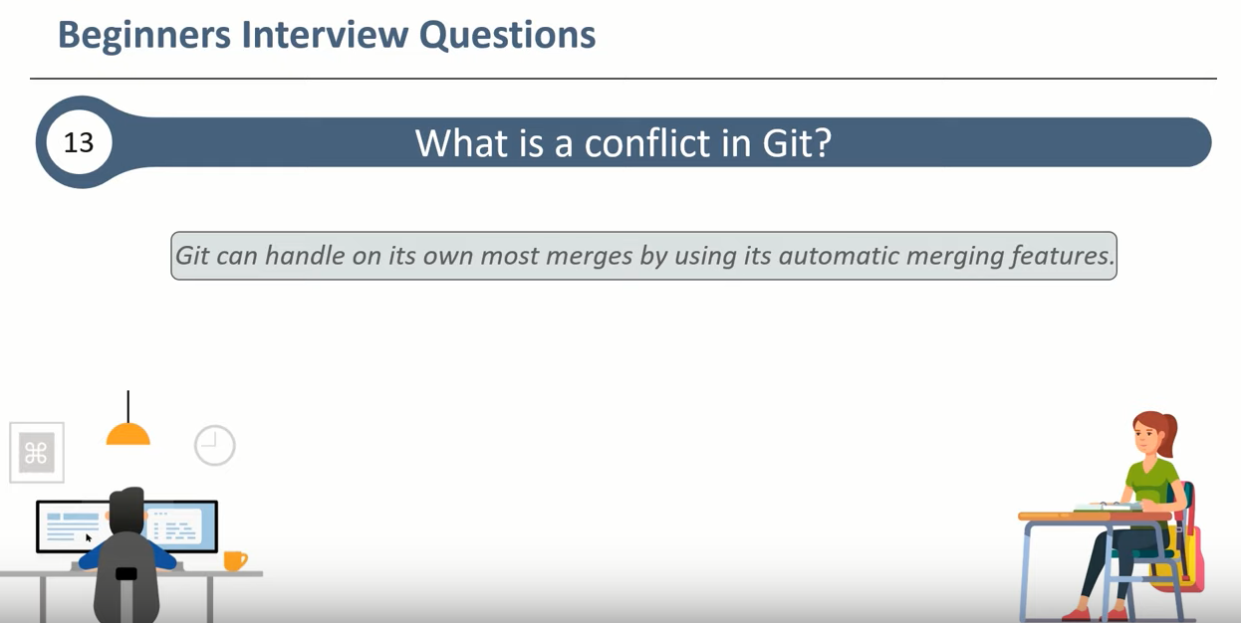

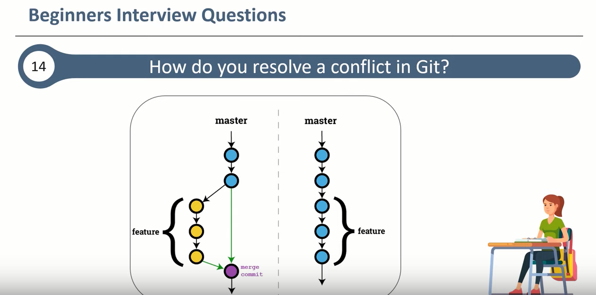

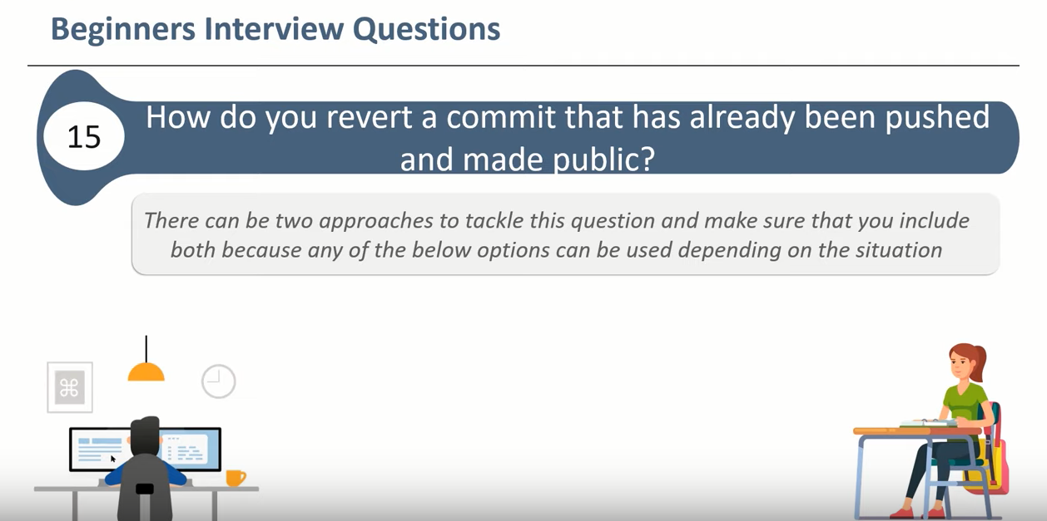

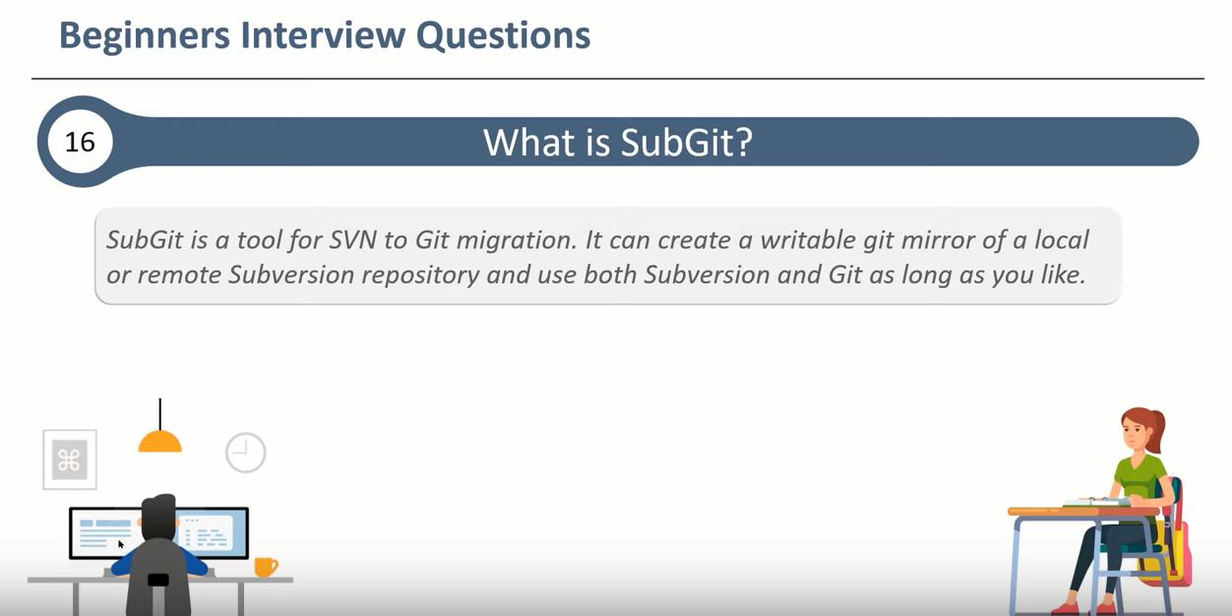

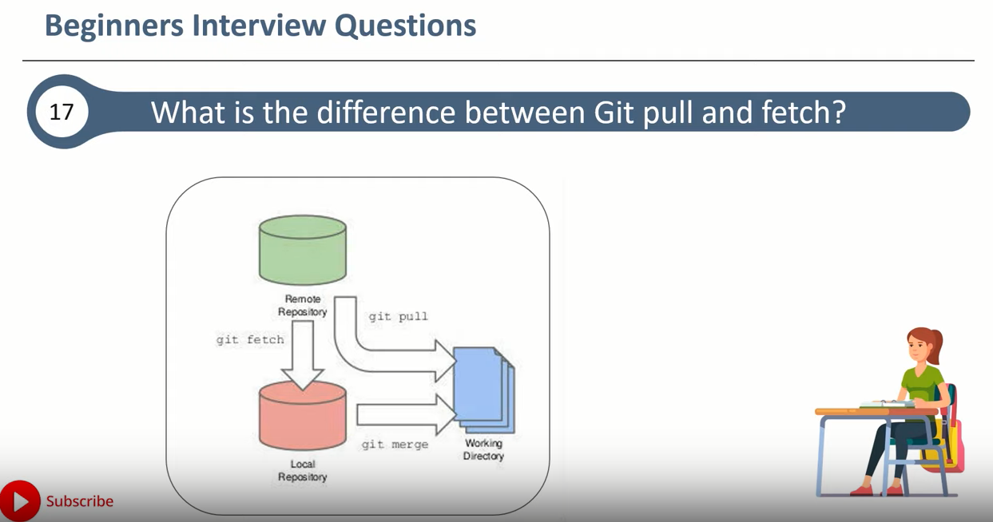

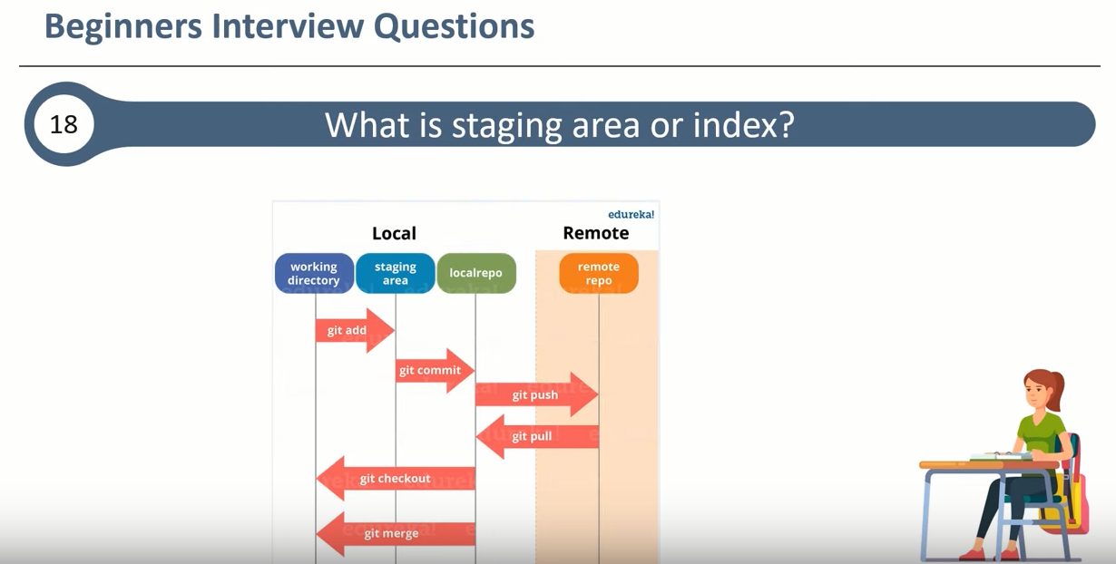

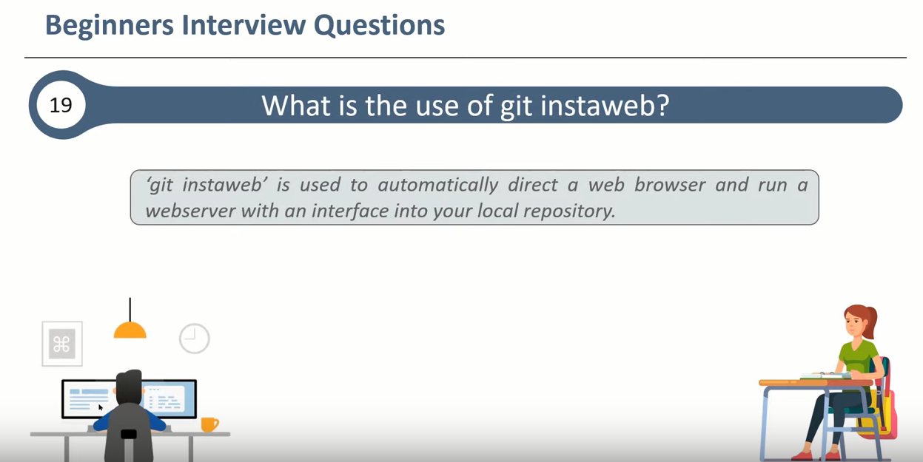

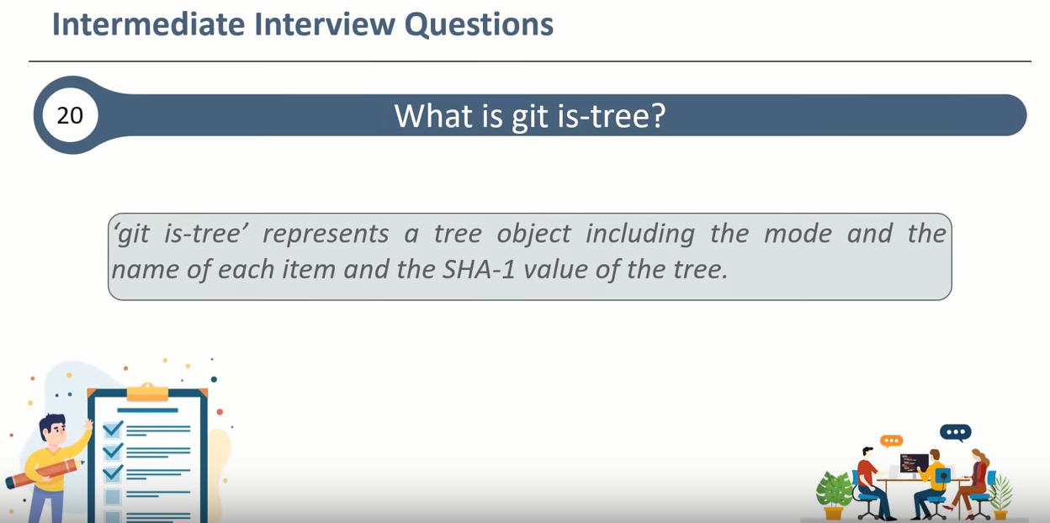

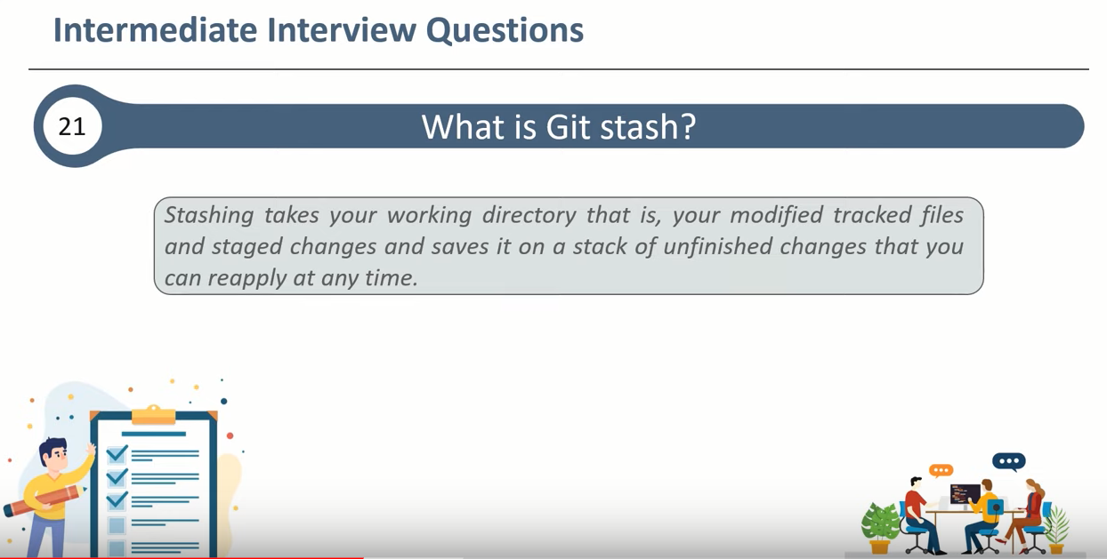

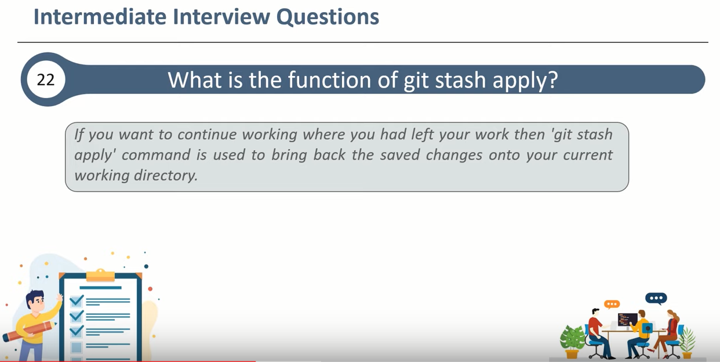

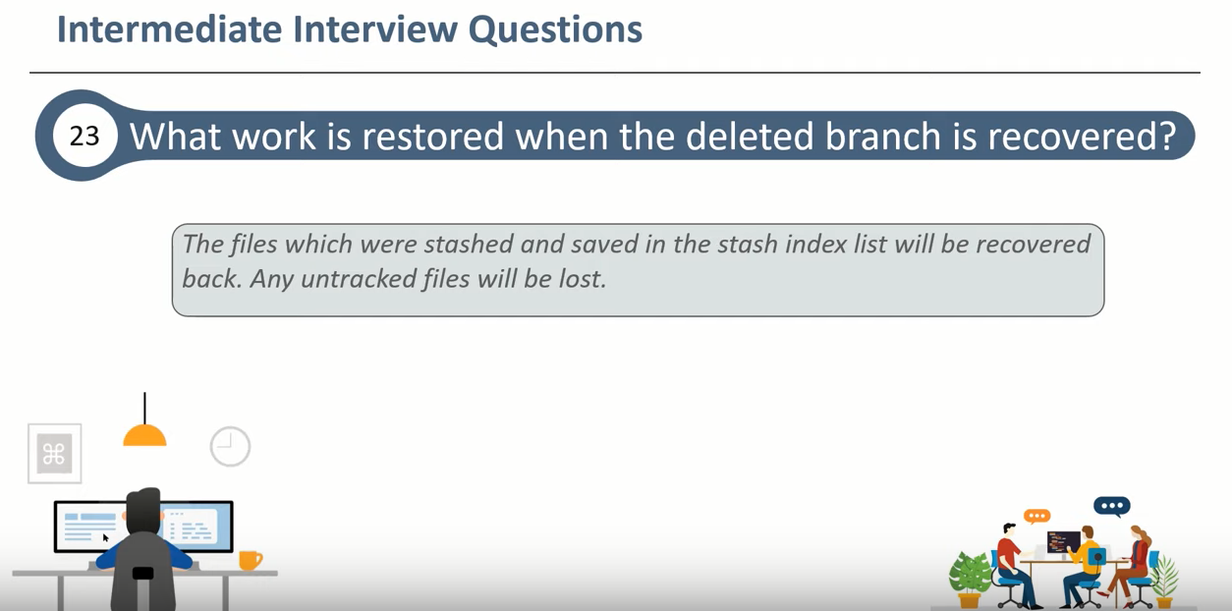

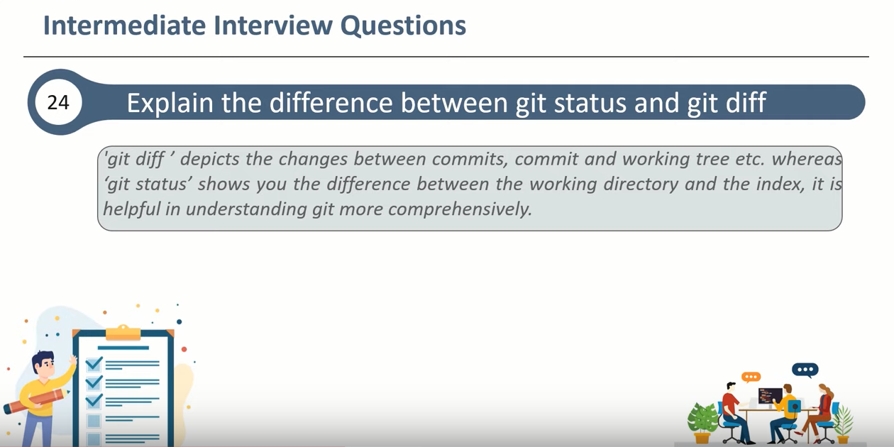

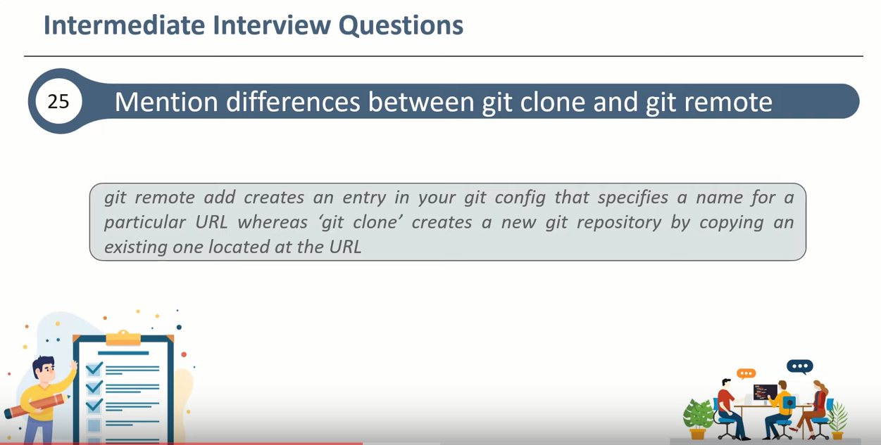

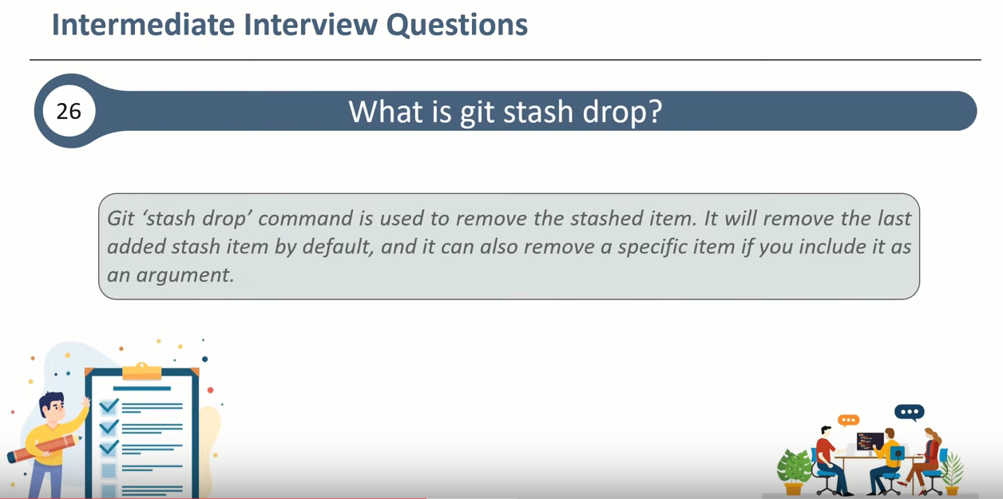

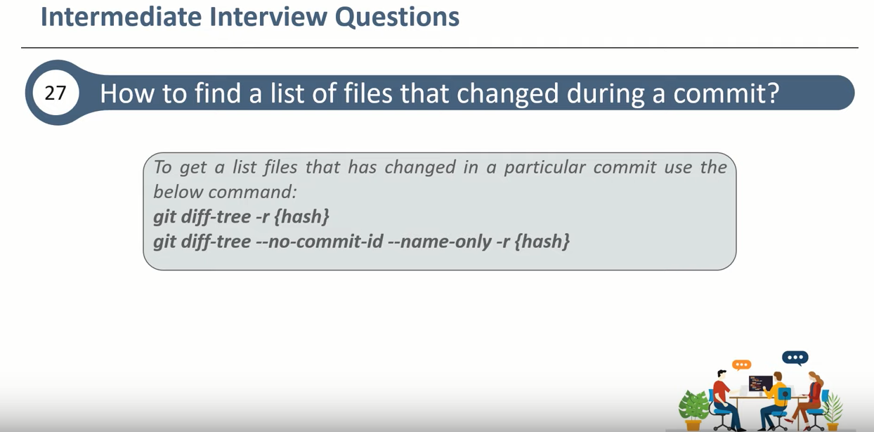

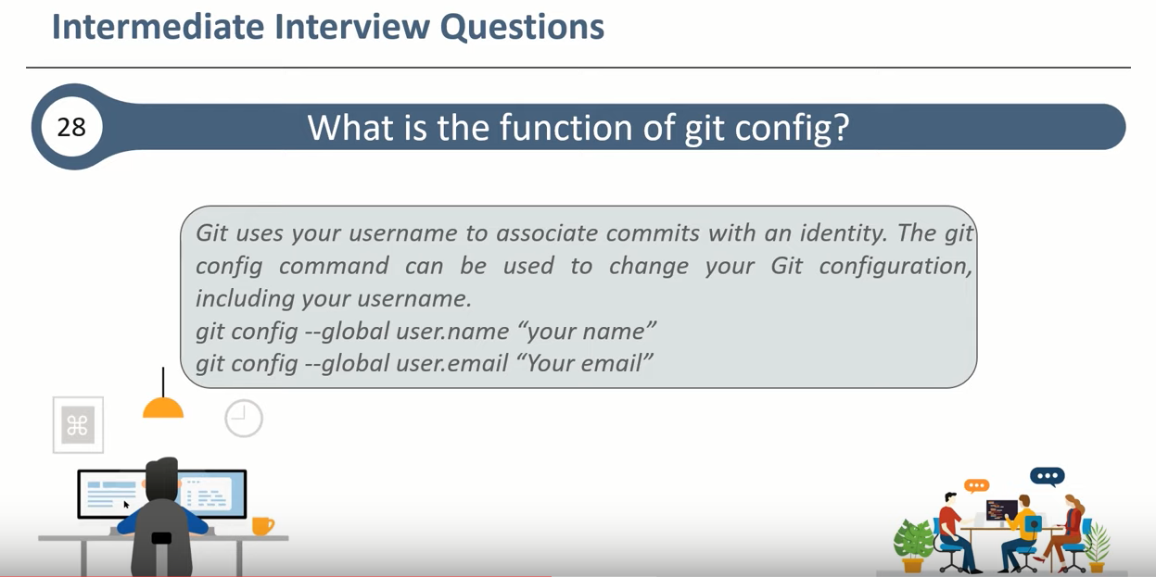

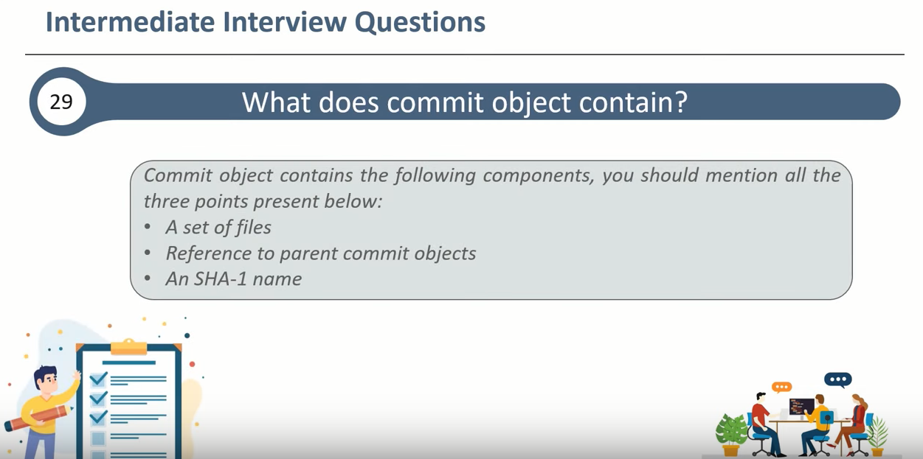

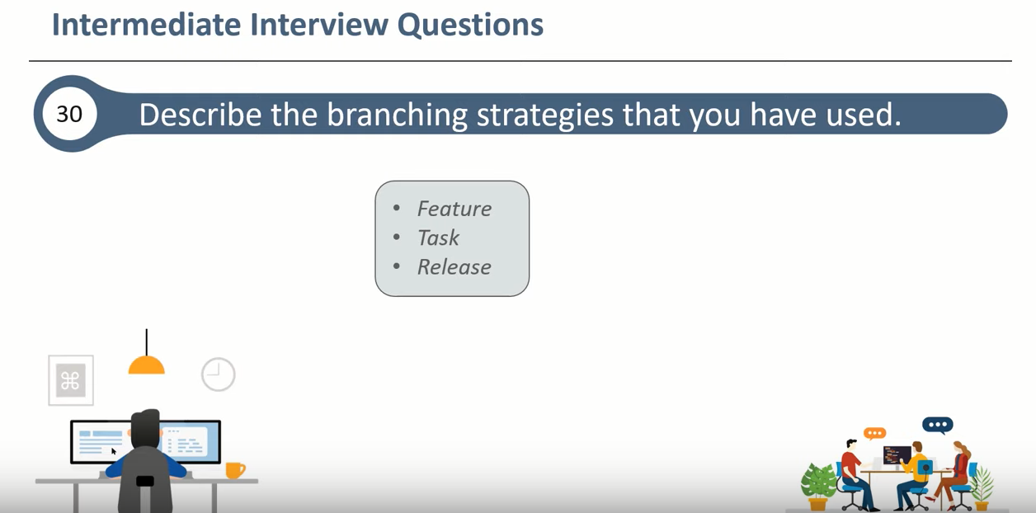

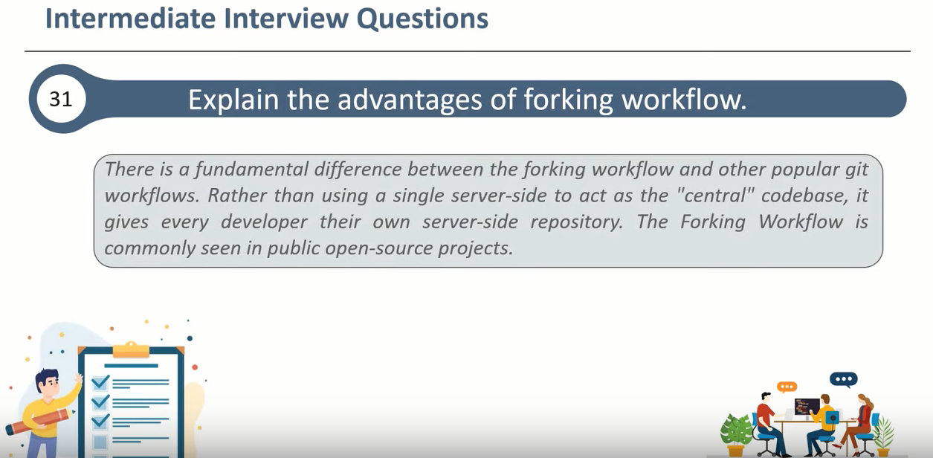

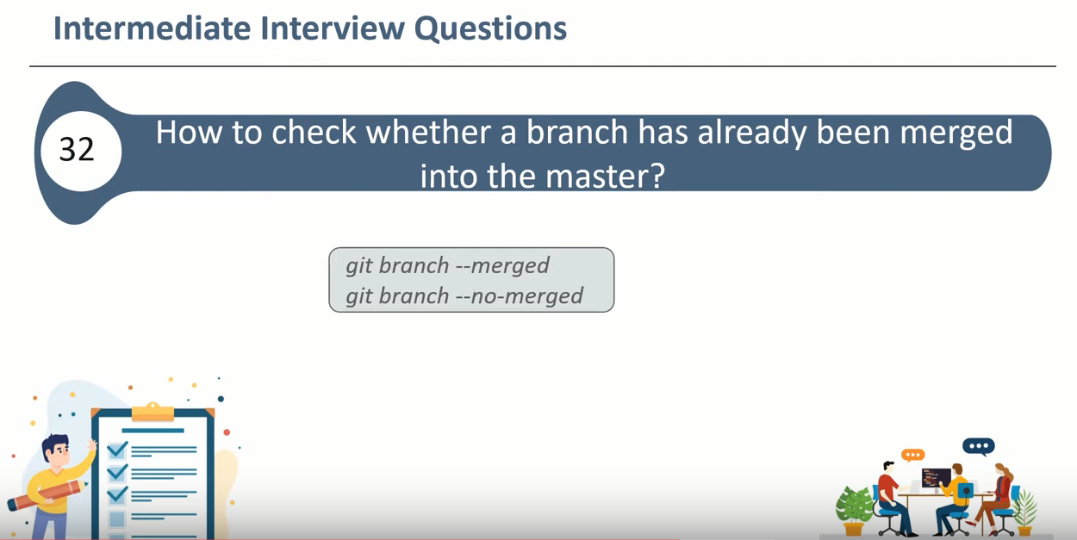

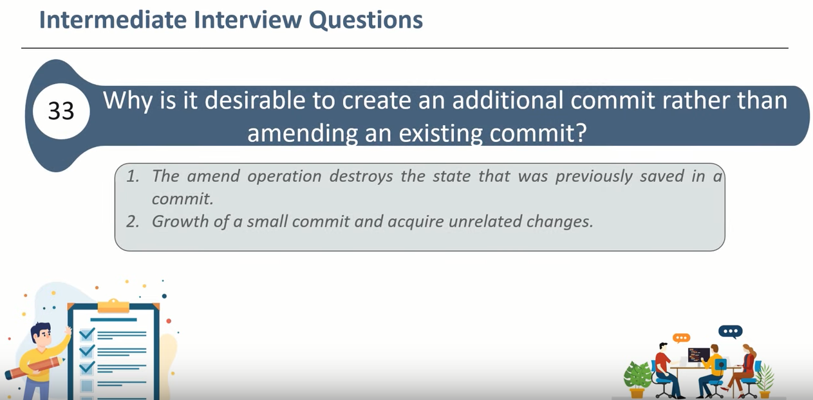

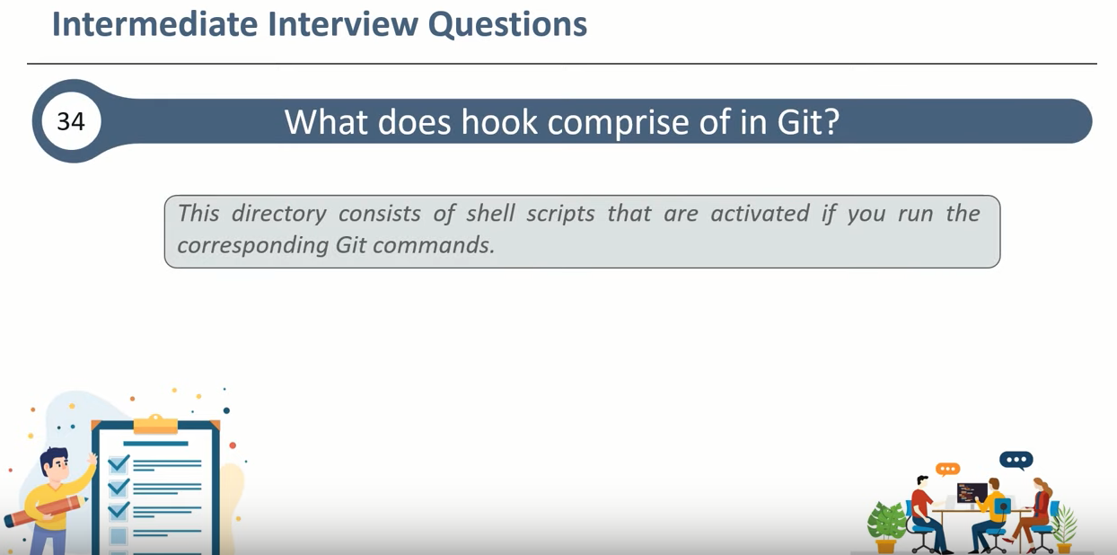

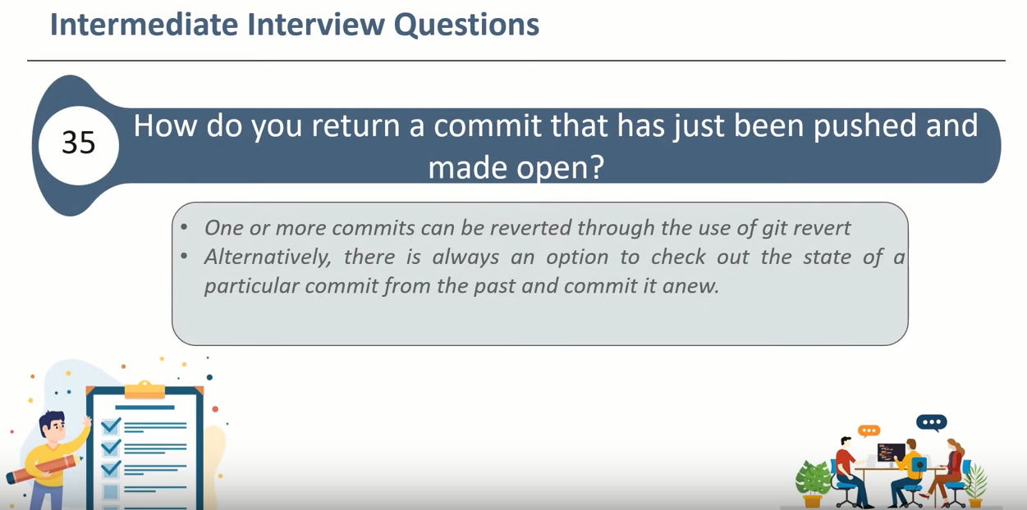

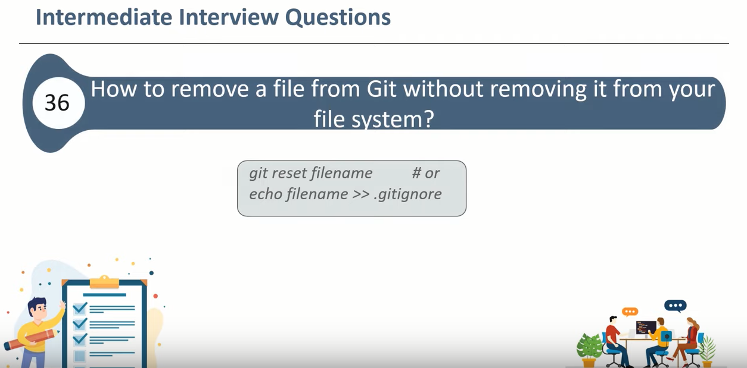

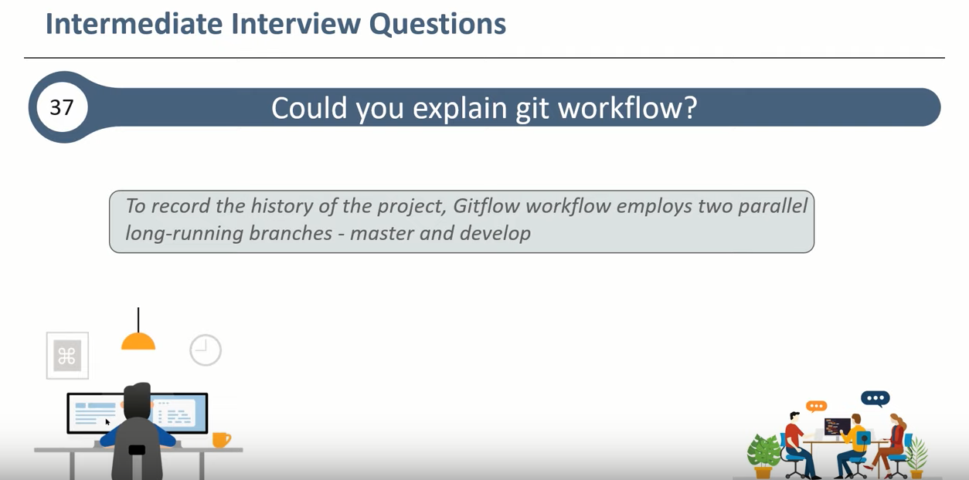

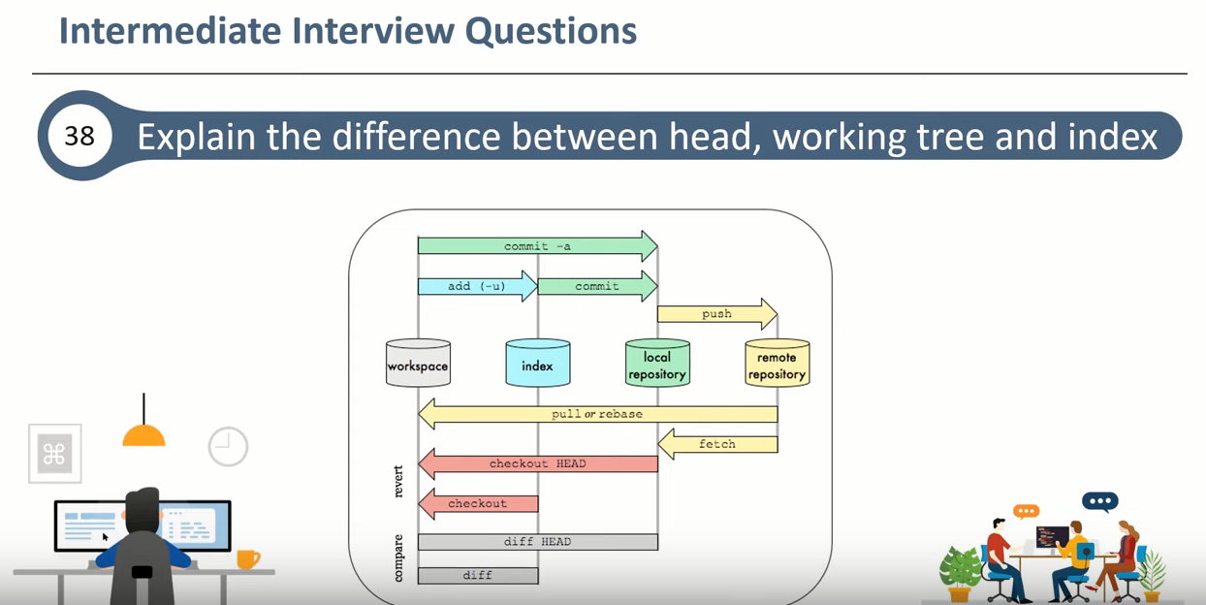

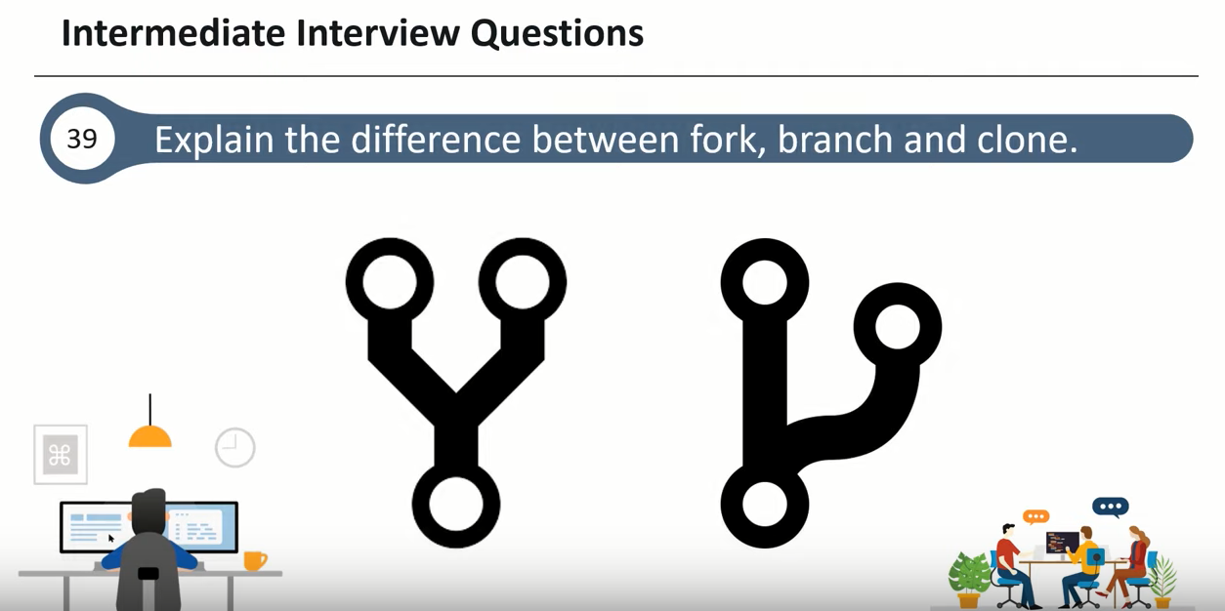

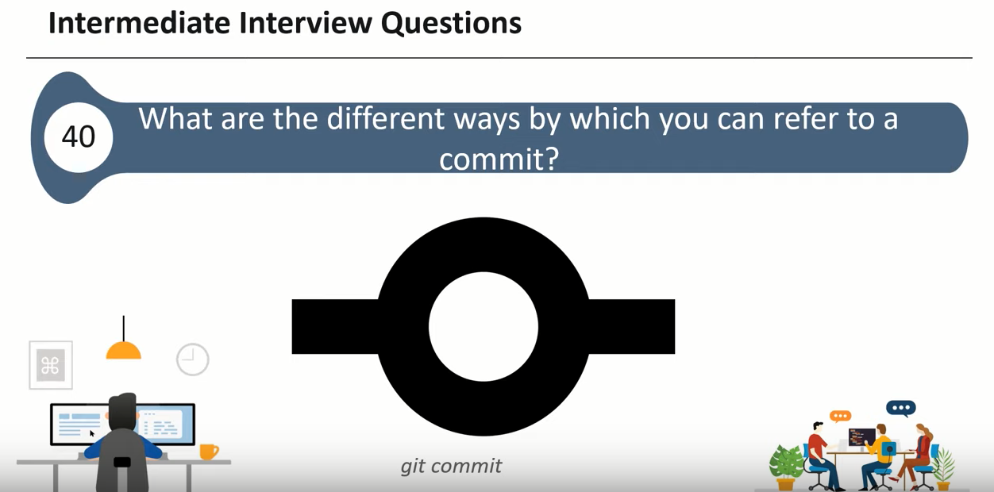

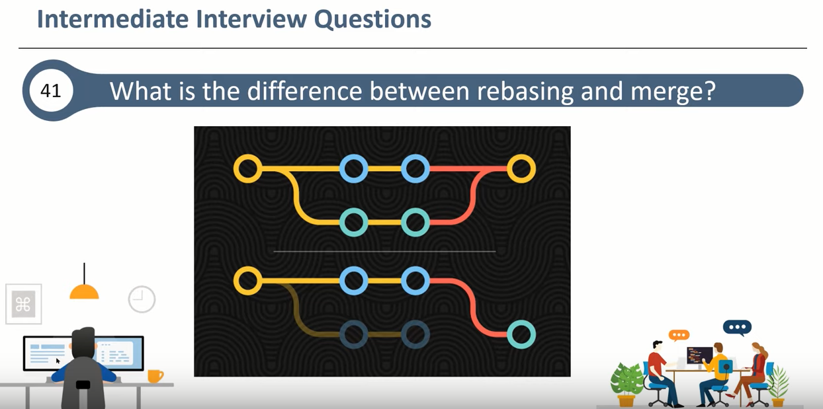

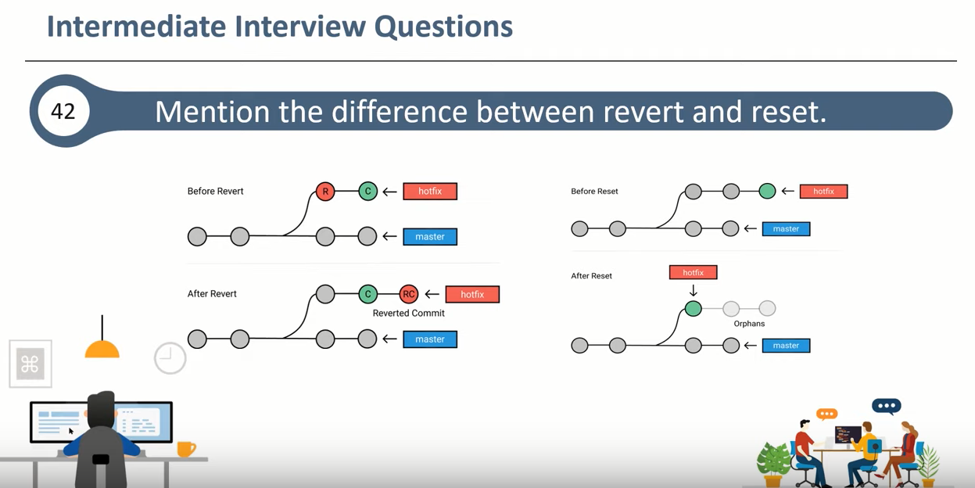

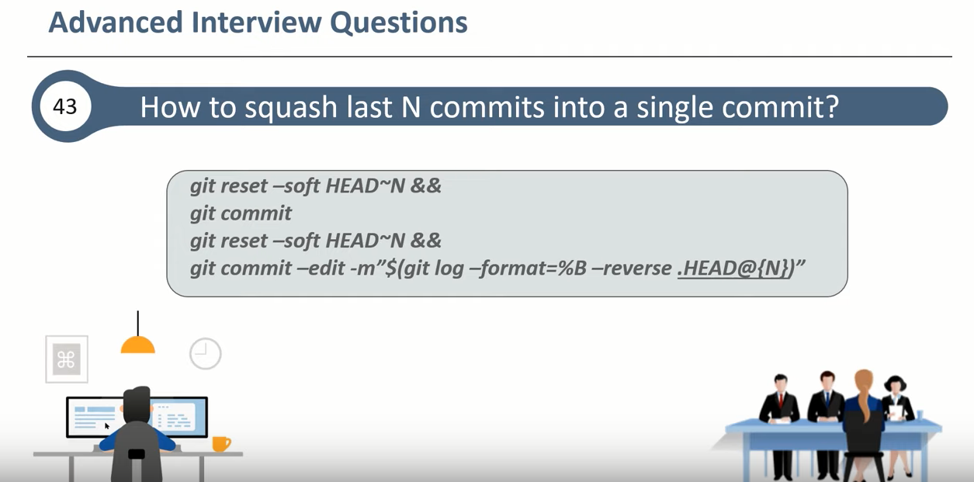

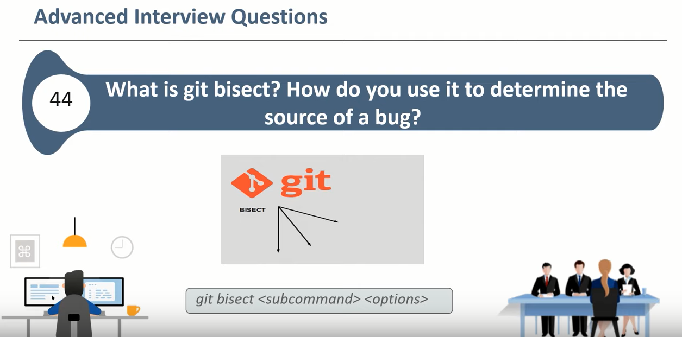

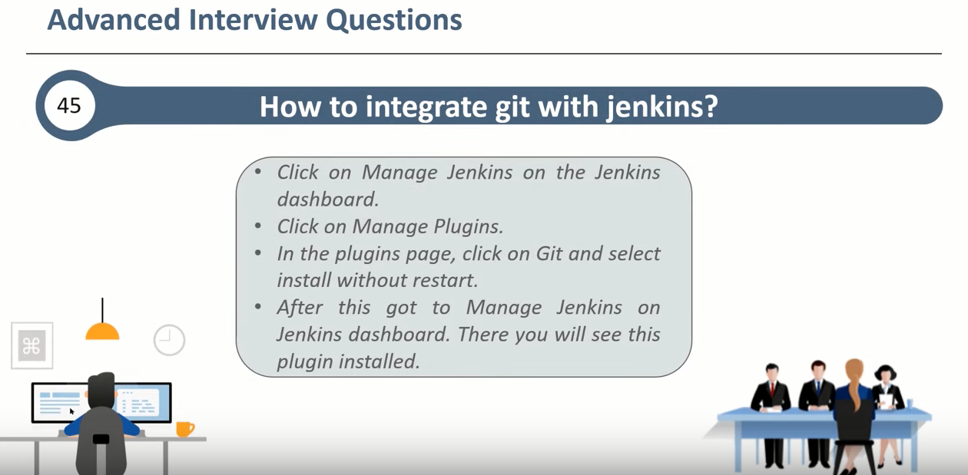

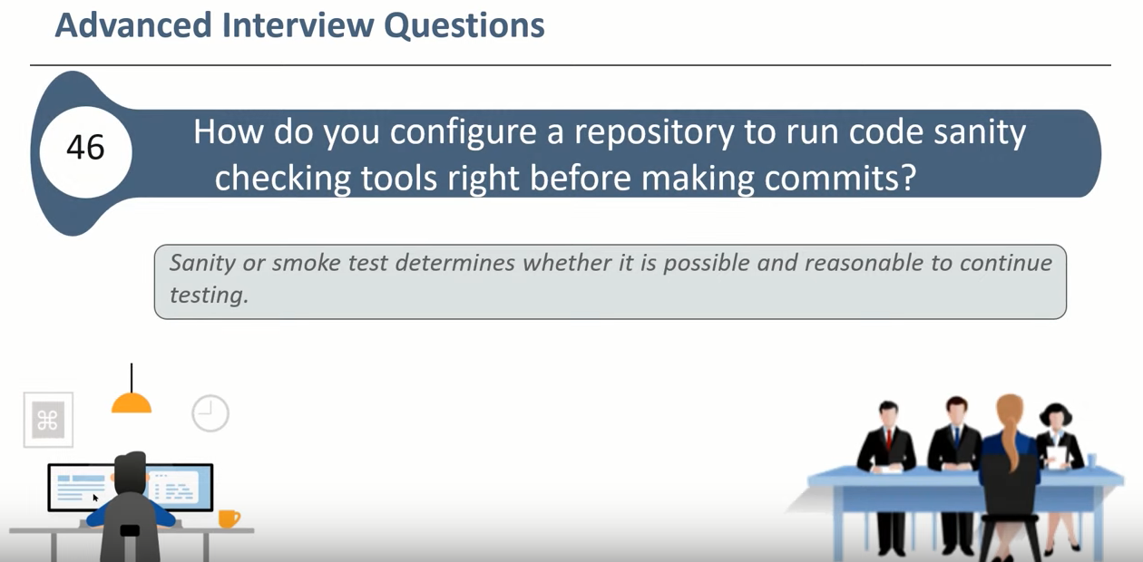

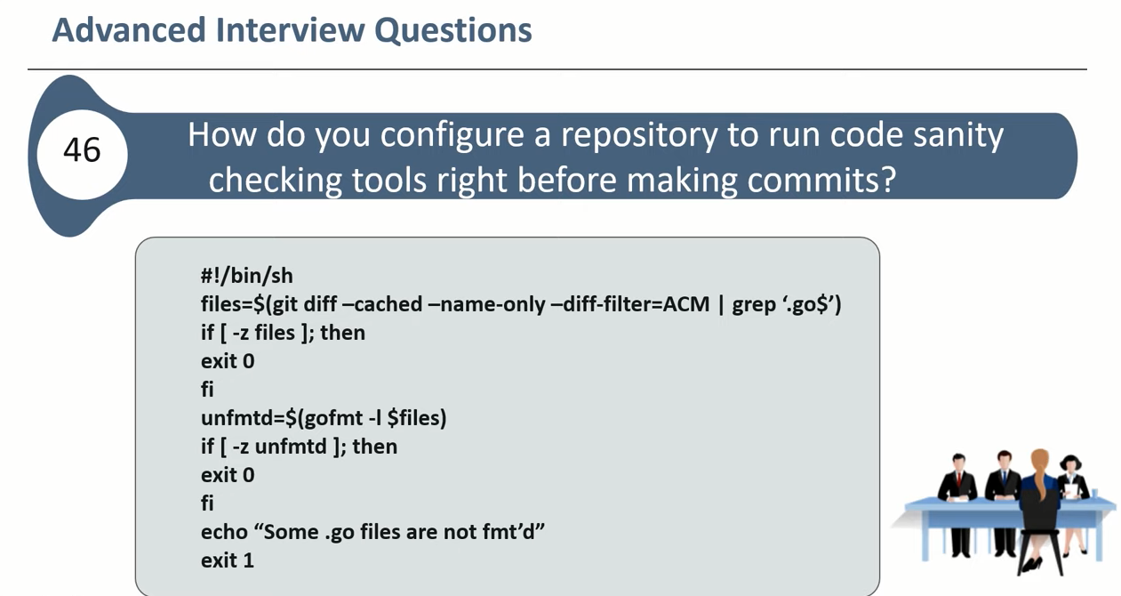

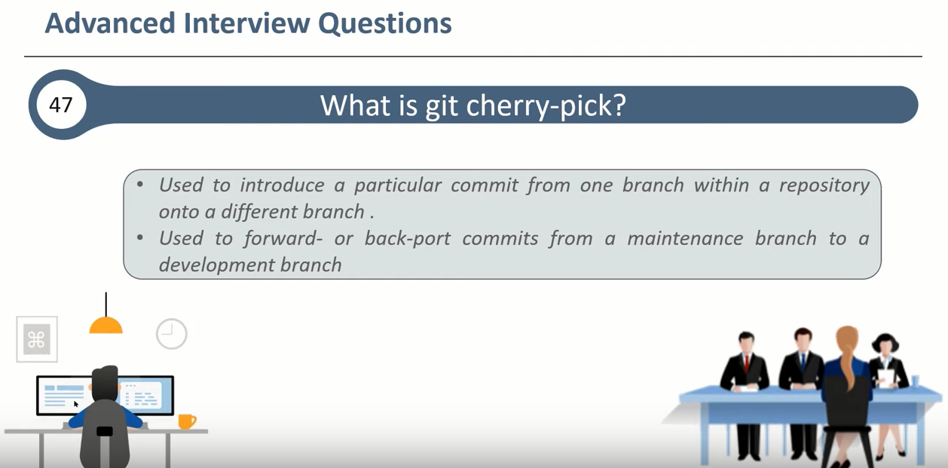

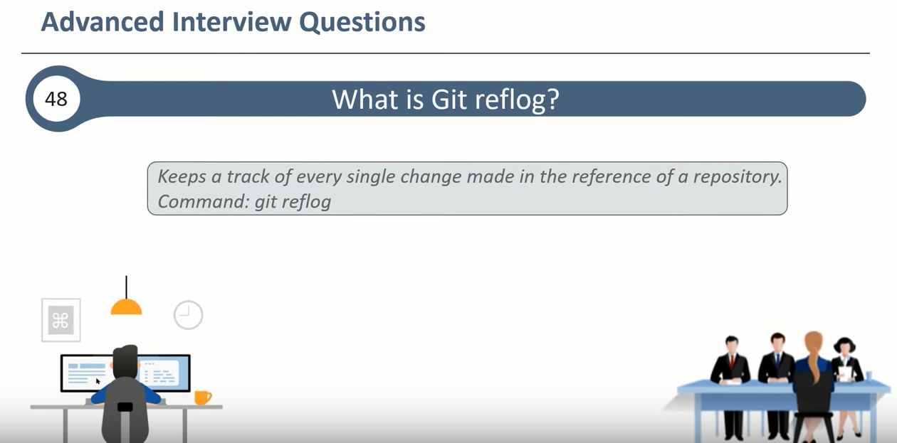

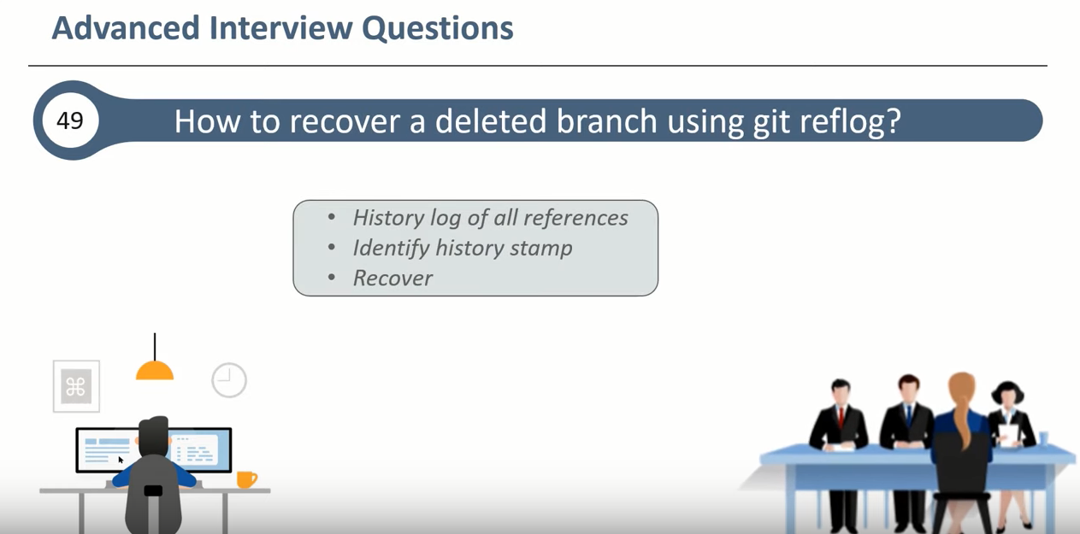

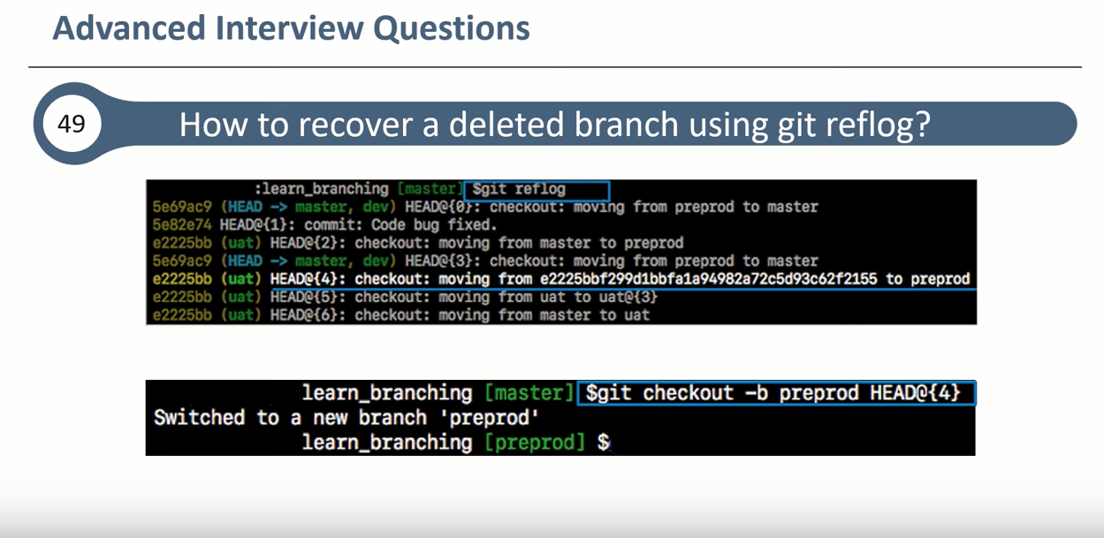

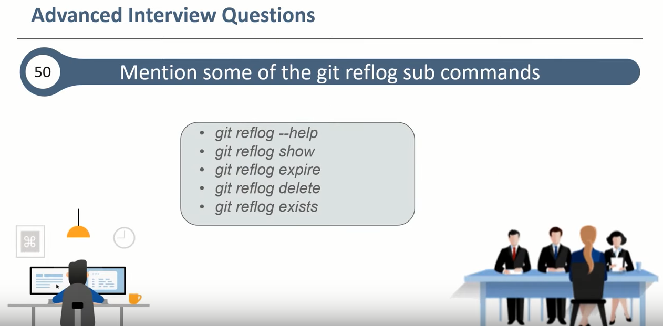

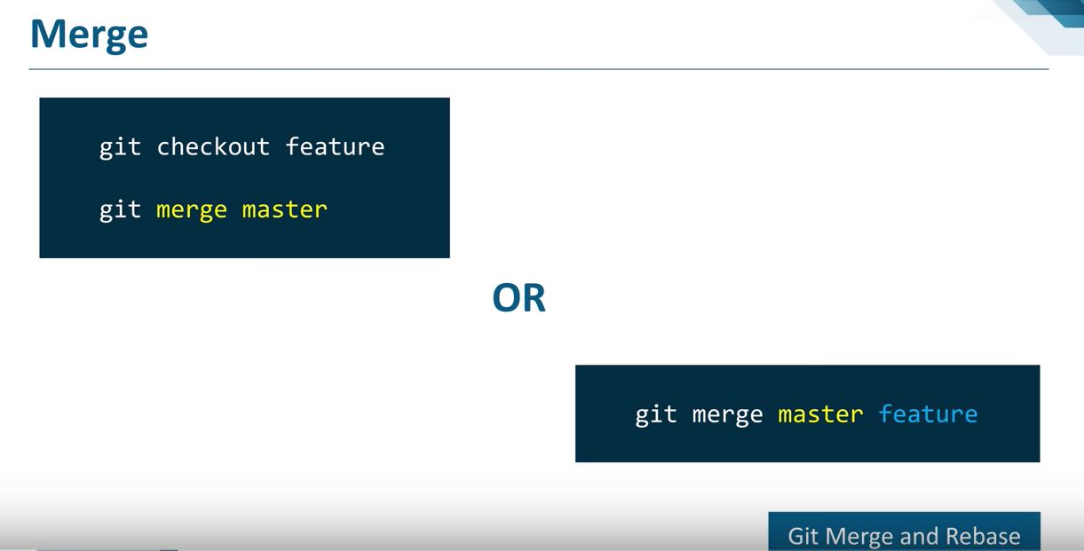

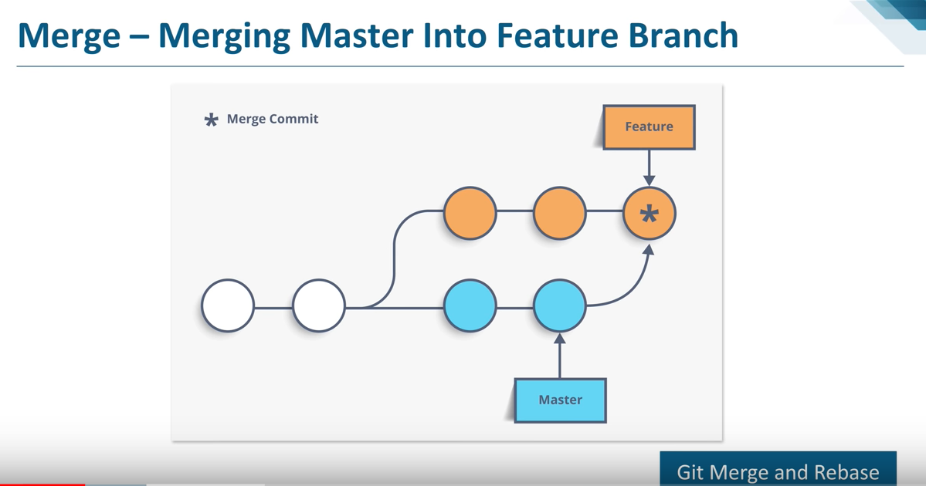

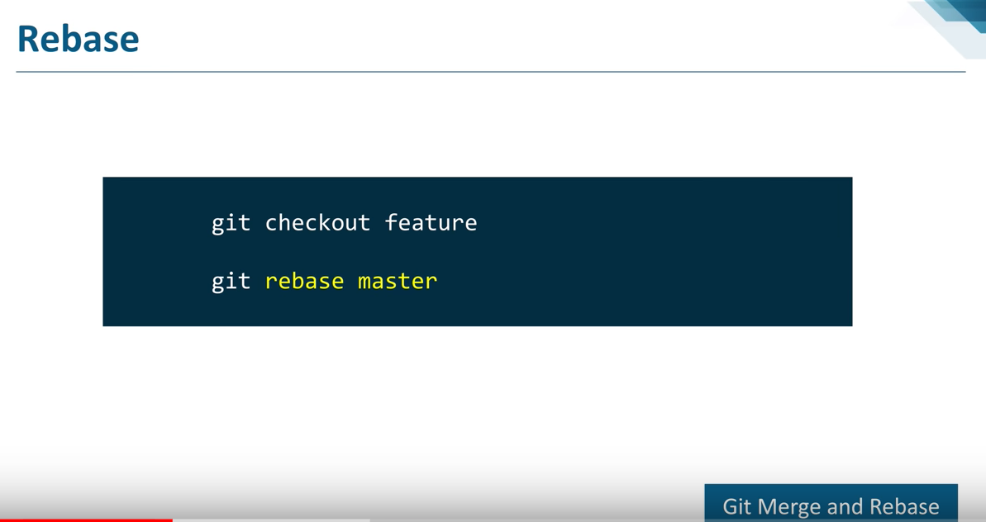

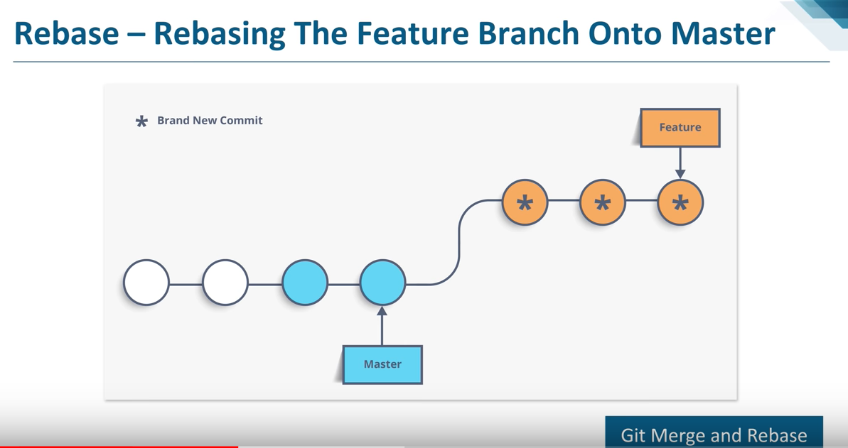

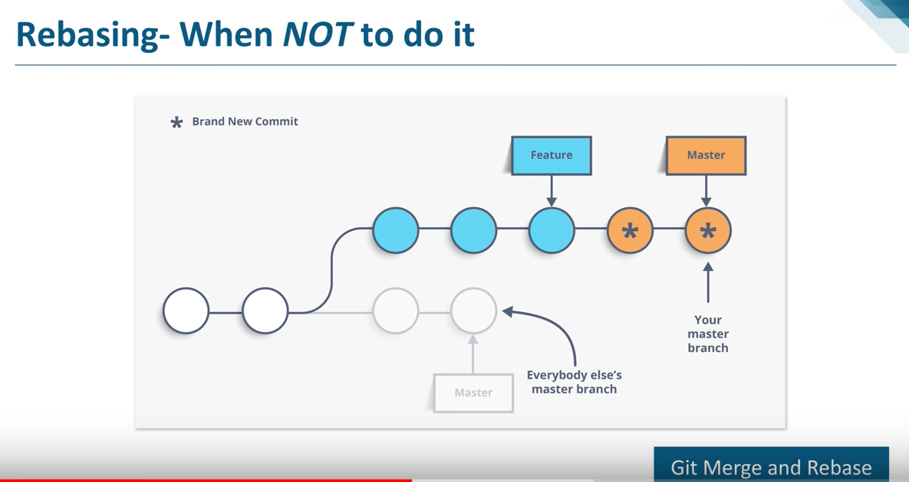

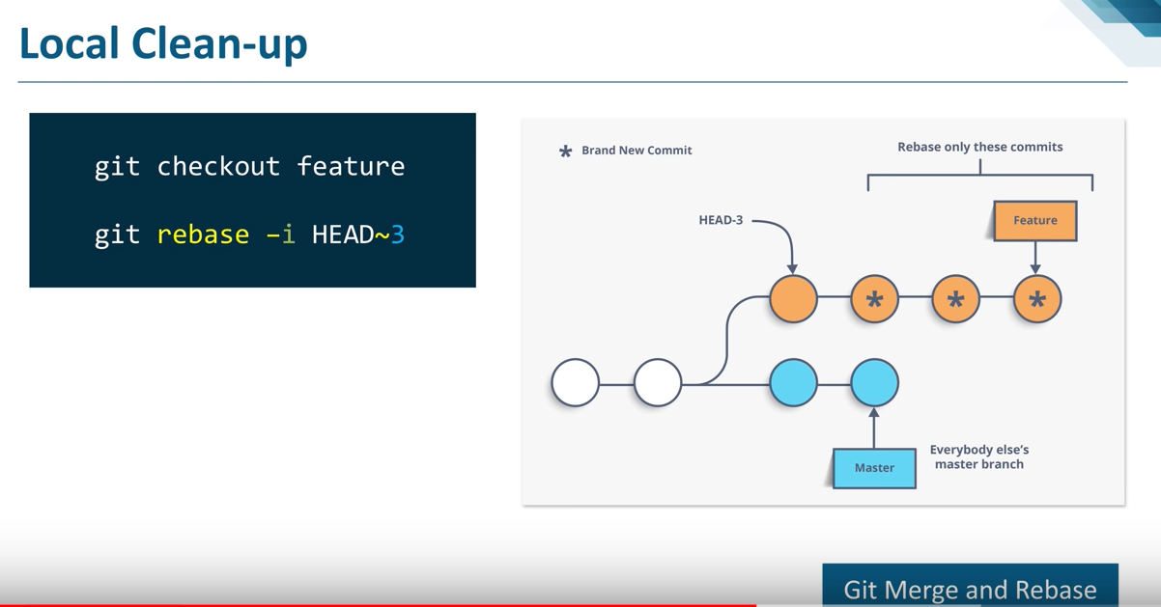

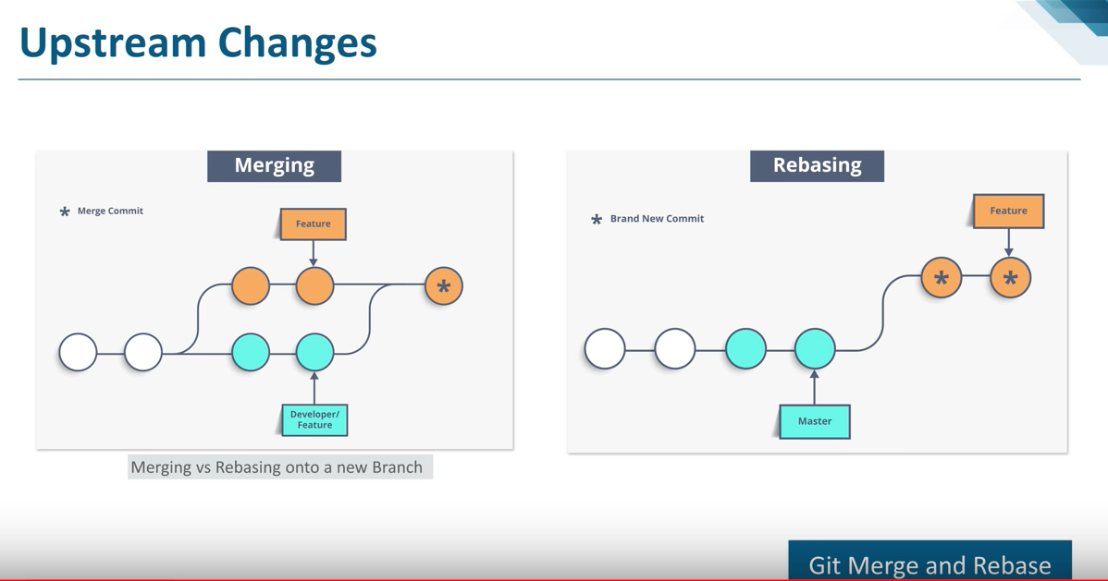

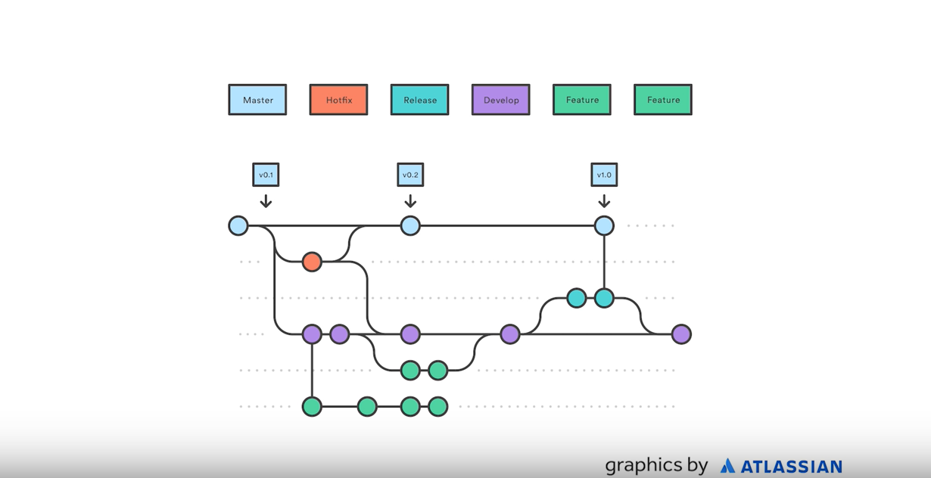

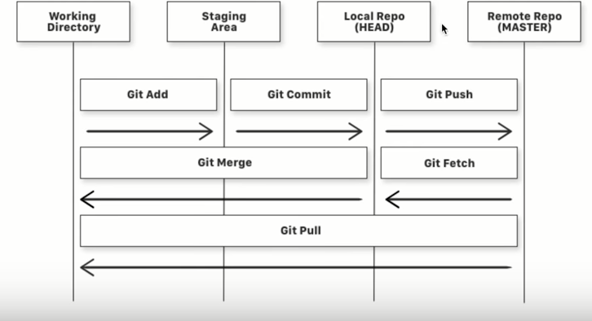

**Generating SSH key-**

1. Run **ssh-keygen** on GIT command prompt
2. **Cat <filepath+filename> -->** filename is file where public key has been saved
3. Go to **GIT HUB** settings then **SSH and GPG keys.**
4. Click **New SSH Key** and enter the key name and paste the key. Then click on **Add SSH key.**
5. To authenticate key. Go to GIT command prompt and run **ssh –T git@github.com**

**Git pull is equal to Git fetch + Git merge**

**Git checkout –b “branchname” is equal to Git branch “branchname” + Git checkout “branchname”**

**Touch file.fileExtension 🡪 creates a file**

**Not to commit a file🡪 1) create file .gitignore using touch .gitignore 2) add the files you want to ignore in .gitignore file. You can also use regular expression.**

**Aliasing a command 🡪 alias graph=’git log --all --decorate --oneline --graph’. Then you can use graph command alone (without using with git)**

1. Git init 🡪 initializes a git repository in the folder/directory
2. Git status 🡪 shows untracked files or updated files that needs to be committed. List the files you have changed and those you still need to add or commit. Shows state of files in working tree, staging area vs last commit in git history.
3. Git add . 🡪 add all files to staging area
4. Git add <filename> 🡪 adds specific file to staging (index) area
5. Git commit -m “message”> 🡪 commits all indexed files to git repository
6. Git commit -a -m “message” 🡪 git add all files to index and then commit the changes. It works for files which are already added to index in past.
7. Git commit –am “message” 🡪 adds the file to index and commits.
8. Git commit --amend -m “new message” 🡪 replaces last commit message with the new one.
9. Git log 🡪 list down all past commits. It displays git history.
10. Git log -p 🡪 shows changes done in each commit
11. Git log -- <filename> 🡪 history of specific file
12. Git log --all --decorate --oneline --graph 🡪 shows commit history graph
13. Git diff 🡪 shows changes between commits, commit and working tree etc. Basically difference in staged and unstaged files which have been added to stage/index once. Displays difference in working directory and staging area.
14. Git diff --staged 🡪 shows difference between staged and local repository files.
15. Git diff --cached 🡪 shows difference in staging area and latest commit.
16. Git diff <branch1>.. <branch1> 🡪 gives difference between two branches.
17. Git diff <hash 1> <hash 2> 🡪 shows difference between two commits.
18. Git reset 🡪 moves all last added files from index directory to working directory
19. Git reset <fileName.fileExtension> 🡪 removes the file from staging area to working directory.
20. Git reset --soft <hash code of commit> 🡪 deletes specific commit from history. It keeps our changes in the staging directory.
21. Git reset --hard <id of commit> --> goes to particular commit. HEAD is pointing to this id (file)
22. Git reset HEAD <filename> 🡪 reset file from local repository to staged area
23. Git revert <id of commit> 🡪 it is used to revert a commit. Hash code of older commits are not changed. And new commit is added at top.
24. Git checkout <file> 🡪 if you have modified the file and not added it to staging area and you want to move to the last indexed stage.
25. Git checkout <id of commit> 🡪 goes to specific commit, not through a branch. It results in a detached HEAD state.
26. Git checkout -- . –> revert the changes, if not added to index
27. Git checkout -- <filename> 🡪 revert the changes made in file in working tree. Replaces new file with staging area file.
28. Git checkout <id of commit> -- <filename> 🡪 brings file to staging area
29. Git checkout <id of commit> <filename> 🡪 retrieve a file from previous commit
30. Git checkout –b <new branch name> 🡪 creates new branch and switches to it.
31. Git checkout –b <new branch name> <id of commit> 🡪 creates a new branch with specific commit
32. Git checkout –b <new branch name> HEAD~4 🡪goes back 4 commit from HEAD
33. Git merge <branch going to be merged to current branch> --> merge the specified branch into current branch. It works for fast-forward and 3-way merges.
34. Git merge --abort 🡪 it aborts a merge during merge conflict situations.
35. Git branch 🡪 tells in which branch you are currently in and other branches present in repository
36. Git branch –a 🡪 it displays local and remote branches.
37. Git branch –r 🡪 it lists remote branches.
38. Git branch -D <branch going to be deleted> 🡪 delete specific branch, even if it is not merged.
39. Git branch -d <branch going to be deleted> 🡪 delete specific branch, only when the branch is merged.
40. Git branch <new branch name> 🡪 creates new branch
41. Git branch --merged 🡪shows which branches are merged in current branch
42. Git checkout <branch to switch> 🡪 switches from current branch to specific branch. Head pointer moves to specified branch.
43. Git rm <filename> 🡪 deletes mentioned file from working tree and staged area. rm stands for remove.
44. Git rm --cached <filename> 🡪 to remove file from staging area.
45. Git remote add origin <url of repository> 🡪 establish connection between remote and local repository
46. Git push –u origin <branchname> 🡪 push the code from local repo to git hub. It check in code to particular branch (-u is for upstream)
47. Git push <remote name> <branch name> 🡪 it uploads to remote
48. Git push --all 🡪 pushes all the branches to server repository
49. Git push origin --delete <branch name> 🡪 deletes the specific branch in remote repository.
50. Git clone <url of repository> 🡪 copies all code to local system
51. Git pull origin <branch name> 🡪 pulls the code to system
52. Git clone <url of repository> 🡪 clones a repository
53. Git remote 🡪 displays our remote
54. Git remote –v 🡪 displays full location with remote repository URL.
55. Git fetch <remote name> 🡪 it retrieves/downloads from a remote.
56. Git merge <tracking branch name> 🡪 it merges branch or tracking branch.
57. Git stash 🡪 it removes the new changes done to file only if it is not indexed. It creates stash point. It can be used across branches.
58. Git stash save “message” 🡪 saves the non-commit changes in current branch. It creates stash point with message/description.
59. Git stash apply 🡪 it adds the removed code to the file which was last stashed. Its index is 0. It applies most recent stash.
60. Git stash apply <index> 🡪 it adds removed code of specific stashed. Index needs to be applied from old to new. Vice versa is not possible. It applies specific stash.
61. Git stash list 🡪 shows all stash with index. It lists stash points.
62. Git stash list –p 🡪 list all stash occurred at all stash points and shows difference per stash.
63. Git stash push –m <“message”> 🡪 it adds stash with message
64. Git stash drop <index> 🡪 deletes the stash with specific index
65. Git stash pop 🡪 it applies most recent stash. It is removed from saved stashes.
66. Git stash pop <index> 🡪 adds the removed code to file and deletes the stash.
67. Git stash clear 🡪 deletes all stash
68. Git reflog 🡪 shows history of all updates done in past
69. Git config --global user.name <”username”> 🡪 it is one time job. It is for authentication purpose. --local option is also available.
70. Git config --global user.email <”emailID”> 🡪 it registers your email address.
71. Git config --list 🡪 shows list of config items
72. Git cherry-pick <hash> 🡪 adds specific hash commit to the current branch but this commit will still exits on branch.
73. Git clean –df 🡪 to get rid of untracked files forcefully.

[**Introduction to Git – Core Concepts**](https://www.youtube.com/watch?v=uR6G2v_WsRA)

[**Introduction to Git – Branching and Merging**](https://www.youtube.com/watch?v=FyAAIHHClqI)

[**Introduction to Git - Remotes**](https://www.youtube.com/watch?v=Gg4bLk8cGNo)

Merge conflict -<https://www.youtube.com/watch?v=1MVQYSlgXrI>

GIT - <https://www.youtube.com/watch?v=_OZVJpLHUaI>

GIT HUB - <https://www.youtube.com/watch?v=mVnZVw4KJnc>

Edureka full Git and Git hub - <https://www.youtube.com/watch?v=xuB1Id2Wxak>

[What is Git | What is GitHub | Git Tutorial | GitHub Tutorial | Devops Tutorial | Edureka](https://www.youtube.com/watch?v=xuB1Id2Wxak)

# [Git Tutorial | Git Basics - Branching, Merging, Rebasing | Learn Git | DevOps Tutorial | Edureka](https://www.youtube.com/watch?v=41tsyReTloA)